

OXYGEN – CLEVEDON
Product Name | Oxygen |  |  | Risk Assessment Number |  | 44
Manufacturer | Supplier – BOC |  |  | Product Code |  | 000010021701
Manufacturer Contact Number | 0800 111 333 |  |  | Manufacturer’s CAS Ref.  (on Safety Data Sheet) |  | CAS - 7782-44-7
Manufacturer Safety Data Sheet  (MSDS) | Yes |  |  | Date of MSDS |  | 10/07/2023
Hazard Classifications  (Tick as appropriate) | ☐ |   Explosive | ☐ |   Corrosive | ☐ |   Acute toxicity
Hazard Classifications  (Tick as appropriate) | ☒ |   Flammable | ☐ | Hazardous to the environment | ☐ |   Health hazard/Irritant/Hazardous to the ozone layer
Hazard Classifications  (Tick as appropriate) | ☐ |   Oxidising | ☐ |   Serious health hazard | ☒ |   Gas under pressure
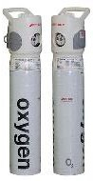 | If patients require oxygen whilst being treated then a mask will be connected to the oxygen cylinder and the valve opened to the correct rate to assist the patient. Oxygen may also be used to nebulise asthmatic patients when used with a nebuliser mask.
Are Any Hazardous Substances Produced by any Processes? | No hazardous combustion products release from the gas.  Oxygen strongly supports combustion and will cause substances to burn vigorously, including some materials that do not normally burn in air. Highly dangerous in the presence of oil, grease, tarry substances and many plastics.  Precautionary statements (CLP)  Prevention : P220 - Keep away from clothing and other combustible materials. P244 - Keep valves and fittings free from oil and grease.  Response : P370+P376 - In case of fire: Stop leak if safe to do so. - Storage : P403 - Store in a well-ventilated place.
Who might it effect?   | Staff Patients Visitors Contractors  Emergency service crews
Controls in Place | ☐ | Total enclosure of the process | ☐ | Partial enclosure of the process | ☒ | General workplace ventilation
Controls in Place | ☐ | Wet methods (to control dust) | ☐ | Respiratory Protection | ☐ | Eye Protection
Controls in Place | ☒ | Gloves | ☐ | Overalls | ☒ | Other – additional door signage
Precautions & Personal Protection   | Good Ventilation and additional door signage  It may react violently with combustible materials such as oil and grease
Emergency First Aid  
  Swallowed:  Ingestion is not considered a potential route of exposure. | In contact with eyes:  Adverse effects not expected from this product.
  Contact with Skin:  Adverse effects not expected from this product. | Inhaled:  Remove victim to uncontaminated area
Action in case of Emergency  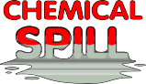 | Fire Officer must be informed that Oxygen Cylinders are present and exactly where they are.  Suitable extinguishing media - Water spray or fog. Product does not burn, use fire control measures appropriate for the surrounding fire.  Unsuitable extinguishing media - Do not use water jet to extinguish.
Environmental Implications   | None
Storage, Disposal & Transport  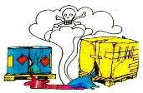 |  |  | Disposal  Empty cylinders must be collected by BOC Gases |  | Transport  Cylinders are transported by BOC
  Storage
  Storage cupboard in room 3..
Overall Assessment of Risk of Current Use of the Substance   | ☒ | Low  A low-risk score means the substance poses minimal danger under normal working conditions and when proper controls (e.g., PPE, ventilation) are in place. Routine monitoring is sufficient, and there is no immediate concern for harm. | ☐ | Medium  A medium-risk score indicates a moderate chance of harm. This suggests that additional precautions or stricter controls may be required to prevent exposure, such as improving handling procedures or enhancing protective measures. | ☐ | High  A high-risk score means there is a significant likelihood of harm, either due to the nature of the substance or insufficient controls. Immediate action is required to eliminate or reduce exposure to an acceptable level, such as substituting the substance, upgrading safety measures, or improving training and supervision.
Improvements  Required | Are the current controls effective? |  |  |  | Yes
Improvements  Required | Does the MSDS suggest any controls that we don't have in place? |  |  |  | No
Improvements  Required | Is air monitoring considered appropriate? |  |  |  | No
Improvements  Required | Can the process be re-engineered? |  |  |  | No
Improvements  Required | Have we considered the use of an alternative, less dangerous substance? |  |  |  | Yes
Assessment Completed by | Name: Stuart Burgess |  | Role: Team Manager |  | Date: 01/03/2026  Review date 01/03/2027



Oxygen, compressed

Safety Data Sheet
according to the REACH Regulation (EC) 1907/2006 amended by Regulation (EU) 2015/830 Reference number: EIGA097A
Issue date: 16/01/2013 Revision date: 10/07/2024 Supersedes version of: 10/07/2023 Version: 2.1
SECTION 1: Identification of the substance/mixture and of the company/undertaking
1.1. Product identifier

Product form : Substance
Name : Oxygen, compressed
Trade name : oxygen
EC Index-No. : 008-001-00-8
EC-No. : 231-956-9
CAS-No. : 7782-44-7

REACH registration No : Listed in Annex IV / V REACH, exempted from registration.

Product code : 000010021701
Formula : O2
Other means of identification : Oxygen (Special Gases), Oxygen (and High Purity Oxygen)
1.2. Relevant identified uses of the substance or mixture and uses advised against
    - Relevant identified uses
Relevant identified uses : Industrial and professional uses. Perform risk assessment prior to use.
Consumer use.
Test gas/Calibration gas. Chemical reaction / Synthesis. Laboratory use.
Food applications.
Shield gas for welding processes. Laser gas.
Welding, cutting, heating and brazing.
It is the responsibility of the end user to ensure that the product as supplied is suitable for its intended use.
Use of the substance/mixture : Balance gas for mixtures.
Carrier gas.
Combustion, melting and cutting processes. Process gas.
Oxidizing agent
Raw material for pharmaceutical products
    - Uses advised against
Uses advised against : Industrial or technical grade is unsuitable for medical and/or food applications or inhalation.
Restrictions on use : None.
1.3. Details of the supplier of the safety data sheet
BOC Ltd. (UK)
Priestley Road, Worsley M28 2UT Manchester Great Britain
T 0800 111 333
ReachSDS@boc.com
1.4. Emergency telephone number
Emergency number : 0800 111 333

SECTION 2: Hazards identification
2.1. Classification of the substance or mixture
Classification according to Regulation (EC) No. 1272/2008 [CLP]

Physical hazards Oxidising Gases, Category 1 H270 Gases under pressure : Compressed gas H280

Full text of H- and EUH-statements: see section 16

Adverse physicochemical, human health and environmental effects No additional information available
2.2. Label elements
Labelling according to Regulation (EC) No. 1272/2008 [CLP] Hazard pictograms (CLP) :

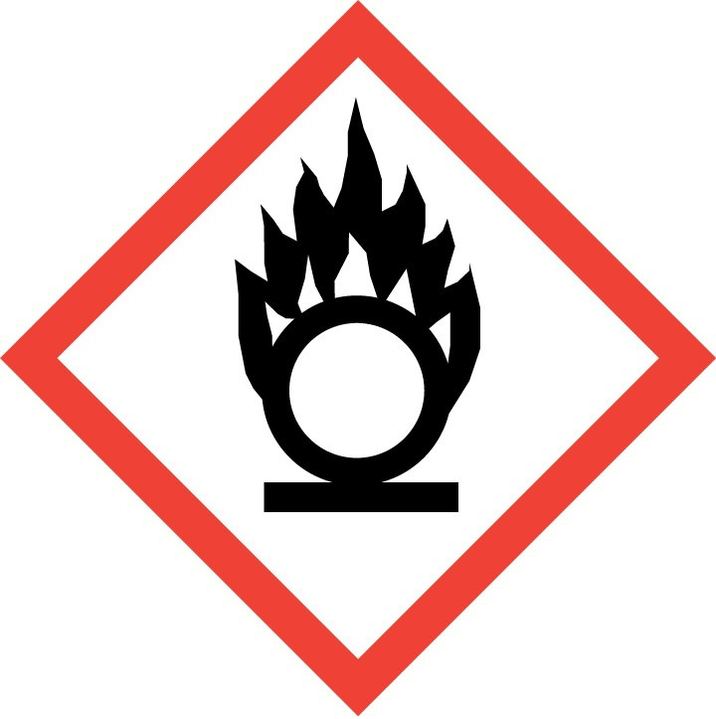
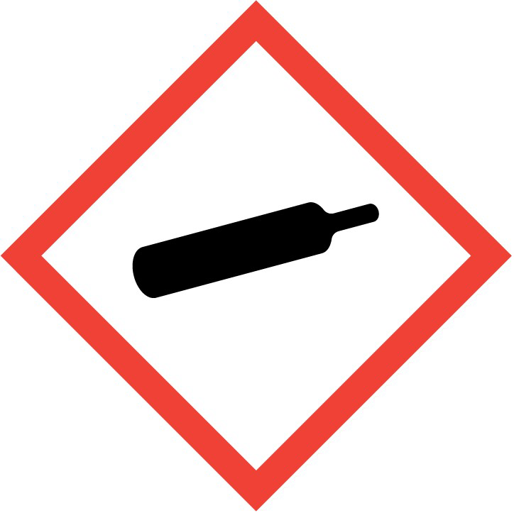
GHS03 GHS04
Signal word (CLP) : Danger
Hazard statements (CLP) : H270 - May cause or intensify fire; oxidiser.
H280 - Contains gas under pressure; may explode if heated.

Precautionary statements (CLP)
- Prevention : P220 - Keep away from clothing and other combustible materials.
P244 - Keep valves and fittings free from oil and grease.
- Response : P370+P376 - In case of fire: Stop leak if safe to do so.
- Storage : P403 - Store in a well-ventilated place.
2.3. Other hazards
Other hazards : Not classified as PBT or vPvB. The substance/mixture has no endocrine disrupting properties.
SECTION 3: Composition/information on ingredients
3.1. Substances

Name | Product identifier | % | Classification according to Regulation (EC) No. 1272/2008 [CLP]
Oxygen, compressed | CAS-No.: 7782-44-7  EC-No.: 231-956-9  EC Index-No.: 008-001-00-8 REACH-no: *1 | 100 | Ox. Gas 1, H270  Press. Gas (Comp.), H280
Full text of H- and EUH-statements: see section 16
Contains no other components or impurities which will influence the classification of the product.
*1: Listed in Annex IV / V REACH, exempted from registration.
*3: Registration not required: Substance manufactured or imported < 1t/y.
3.2. Mixtures
Not applicable

SECTION 4: First aid measures
4.1. Description of first aid measures
First-aid measures after inhalation : Remove victim to uncontaminated area.
First-aid measures after skin contact : Adverse effects not expected from this product. First-aid measures after eye contact : Adverse effects not expected from this product.
First-aid measures after ingestion : Ingestion is not considered a potential route of exposure.
4.2. Most important symptoms and effects, both acute and delayed

Most important symptoms and effects, both acute and delayed
Continuous inhalation of concentrations higher than 75% may cause nausea, dizziness, respiratory difficulty and convulsion.
See section 11.

4.3. Indication of any immediate medical attention and special treatment needed
None.
SECTION 5: Firefighting measures
5.1. Extinguishing media

Suitable extinguishing media : Water spray or fog. Product does not burn, use fire control measures appropriate for the
surrounding fire.
Unsuitable extinguishing media : Do not use water jet to extinguish.
5.2. Special hazards arising from the substance or mixture
Reactivity in case of fire : No reactivity hazard other than the effects described in sub-sections below.
Specific hazards : Supports combustion.
Exposure to fire may cause containers to rupture/explode.
Hazardous combustion products : None.
5.3. Advice for firefighters
Specific methods : Use fire control measures appropriate for the surrounding fire. Exposure to fire and heat radiation may cause gas receptacles to rupture. Cool endangered receptacles with water spray jet from a protected position. Prevent water used in emergency cases from entering sewers and drainage systems.
If possible, stop flow of product.
Use water spray or fog to knock down fire fumes if possible.
Move containers away from the fire area if this can be done without risk.
Special protective equipment for fire fighters : Standard protective clothing and equipment (Self Contained Breathing Apparatus) for fire
fighters.
Standard EN 469 - Protective clothing for firefighters. Standard - EN 659: Protective gloves for firefighters.
Standard EN 137 - Self-contained open-circuit compressed air breathing apparatus with full face mask.
SECTION 6: Accidental release measures
6.1. Personal precautions, protective equipment and emergency procedures

    - For non-emergency personnel
Emergency procedures : Act in accordance with local emergency plan. Try to stop release. Evacuate area. Eliminate ignition sources. Ensure adequate air ventilation. See section 8 of the SDS for more information on personal protective equipment.

    - For emergency responders
Emergency procedures : Monitor concentration of released product. Wear self-contained breathing apparatus when entering area unless atmosphere is proved to be safe. See section 5.3 of the SDS for more information.
6.2. Environmental precautions
Try to stop release.
6.3. Methods and material for containment and cleaning up

Methods and material for containment and cleaning up
: Ventilate area.

6.4. Reference to other sections
See also sections 8 and 13.
SECTION 7: Handling and storage
7.1. Precautions for safe handling

Safe use of the product : Use only oxygen approved lubricants and oxygen approved sealings.
Use only with equipment cleaned for oxygen service and rated for container pressure. Keep equipment free from oil and grease. For more guidance, refer to the EIGA Doc. 33 - Cleaning of Equipment for Oxygen Service downloadable at http://www.eiga.eu.
Use no oil or grease.
The product must be handled in accordance with good industrial hygiene and safety procedures.
Only experienced and properly instructed persons should handle gases under pressure. Consider pressure relief device(s) in gas installations.
Ensure the complete gas system was (or is regularily) checked for leaks before use. Do not smoke while handling product.
Use only properly specified equipment which is suitable for this product, its supply pressure and temperature. Contact your gas supplier if in doubt.
Avoid suck back of water, acid and alkalis. Do not breathe gas.
Safe handling of the gas receptacle : Refer to supplier's container handling instructions.
Do not allow backfeed into the container.
Protect containers from physical damage; do not drag, roll, slide or drop.
When moving cylinders, even for short distances, use a cart (trolley, hand truck, etc.) designed to transport cylinders.
Leave valve protection caps in place until the container has been secured against either a wall or bench or placed in a container stand and is ready for use.
If user experiences any difficulty operating valve discontinue use and contact supplier. Never attempt to repair or modify container valves or safety relief devices.
Damaged valves should be reported immediately to the supplier.
Keep container valve outlets clean and free from contaminants particularly oil and water. Replace valve outlet caps or plugs and container caps where supplied as soon as container is disconnected from equipment.
Close container valve after each use and when empty, even if still connected to equipment. Never attempt to transfer gases from one cylinder/container to another.
Never use direct flame or electrical heating devices to raise the pressure of a container.
Do not remove or deface labels provided by the supplier for the identification of the content of the container.
Suck back of water into the container must be prevented. Open valve slowly to avoid pressure shock.

7.2. Conditions for safe storage, including any incompatibilities

Conditions for safe storage, including any incompatibilities
: Segregate from flammable gases and other flammable materials in store. Observe all regulations and local requirements regarding storage of containers. Containers should not be stored in conditions likely to encourage corrosion.
Container valve guards or caps should be in place.
Containers should be stored in the vertical position and properly secured to prevent them from falling over.
Stored containers should be periodically checked for general condition and leakage. Keep container below 50°C in a well ventilated place.
Store containers in location free from fire risk and away from sources of heat and ignition. Keep away from combustible materials.

7.3. Specific end use(s)
None.
SECTION 8: Exposure controls/personal protection
8.1. Control parameters

8.1.1 National occupational exposure and biological limit values No additional information available
    - Recommended monitoring procedures No additional information available
    - Air contaminants formed
No additional information available
    - DNEL and PNEC

Oxygen, compressed (7782-44-7)
DNEL/DMEL (additional information)
Additional information | None available.
PNEC (additional information)
Additional information | None available.
Additional information : None available.
    - Control banding
No additional information available
8.2. Exposure controls
    - Appropriate engineering controls Appropriate engineering controls:
Avoid oxygen rich (>23,5%) atmospheres. Gas detectors should be used when oxidising gases may be released. Provide adequate general and local exhaust ventilation. Consider the use of a work permit system e.g. for maintenance activities. Systems under pressure should be regularily checked for leakages.
    - Personal protection equipment Personal protective equipment:
A risk assessment should be conducted and documented in each work area to assess the risks related to the use of the product and to select the PPE that matches the relevant risk. The following recommendations should be considered: PPE compliant to the recommended EN/ISO standards should be selected.


Personal protective equipment symbol(s):
      - Eye and face protection Eye protection:
Wear safety glasses with side shields.
Standard EN 166 - Personal eye-protection - specifications
      - Skin protection Hand protection:
Wear working gloves when handling gas containers.
Standard EN 388 - Protective gloves against mechanical risks, performance level 1 or higher.

Other skin protection
Consider the use of flame resistant safety clothing. Standard EN ISO 14116 - Limited flame spread materials. Wear safety shoes while handling containers.
Standard EN ISO 20345 - Personal protective equipment - Safety footwear.

Other information:
Consider the use of flame resistant safety clothing. Standard EN ISO 14116 - Limited flame spread materials. Wear safety shoes while handling containers.
Standard EN ISO 20345 - Personal protective equipment - Safety footwear.
      - Respiratory protection Respiratory protection:
None necessary.
Self contained breathing apparatus is recommended, where unknown exposure may be expected, e.g. during maintenance activities on installation systems.
Standard EN 137 - Self-contained open-circuit compressed air breathing apparatus with full face mask.
      - Thermal hazards Thermal hazard protection:
None in addition to the above sections.
    - Environmental exposure controls Environmental exposure controls:
Refer to local regulations for restriction of emissions to the atmosphere. See section 13 for specific methods for waste gas treatment.
SECTION 9: Physical and chemical properties
9.1. Information on basic physical and chemical properties

Appearance
Molecular mass : 32 g/mol
Physical state : Gas
Form : Compressed gas
Colour : Colourless.
Odour : Odourless.
Odour threshold : Odour threshold is subjective and inadequate to warn of overexposure.
pH : Not applicable for gases and gas mixtures.
Relative evaporation rate (butylacetate=1) : No data available Melting point : -219 °C
Freezing point : No data available
Boiling point : -183 °C

Flash point : Not applicable for gases and gas mixtures.
Critical temperature : -118 °C
Auto-ignition temperature : Non flammable.
Decomposition temperature : Not applicable.
Flammability (solid, gas) : Non flammable.
Vapour pressure : Not applicable.
Vapour pressure at 50°C : Not applicable.
Critical pressure : 5043 kPa
Relative vapour density at 20°C : Not applicable.
Relative density : 1.1 EC-TEMP: 0; EC-PRESS: 1013,25-KPA; EC-REFMAT: Water
Density : Not applicable for gases and gas mixtures.
Relative gas density : 1.1
Solubility : Water:39 mg/l
Partition coefficient n-octanol/water (Log Pow) : Not applicable for gas mixtures. Partition coefficient n-octanol/water (Log Kow) : Not applicable for inorganic products. Viscosity, kinematic : No reliable data available.
Viscosity, dynamic : No reliable data available.
Explosive properties : No data available
Oxidising properties : Oxidiser.
Explosive limits : Not known.
Lower explosive limit (LEL) : Not applicable.
Upper explosive limit (UEL) : Not applicable.
Particle characteristics : Not applicable for gases and gas mixtures.
Nanoforms are not relevant for gases and gas mixtures.
9.2. Other information
Gas group : Compressed gas
SECTION 10: Stability and reactivity
10.1. Reactivity

No reactivity hazard other than the effects described in sub-sections below.
10.2. Chemical stability
Stable under normal conditions.
10.4. Conditions to avoid
Avoid moisture in installation systems.
10.3. Possibility of hazardous reactions
Violently oxidises organic material.
10.5. Incompatible materials
Consider the potential toxicity hazard due to the presence of chlorinated or fluorinated polymers in high pressure (> 30 bar) oxygen lines in case of combustion. May react violently with combustible materials. May react violently with reducing agents. Keep equipment free from oil and grease. For more guidance, refer to the EIGA Doc. 33 - Cleaning of Equipment for Oxygen Service downloadable at http://www.eiga.eu. For additional information on compatibility refer to ISO 11114.
10.6. Hazardous decomposition products
None.
SECTION 11: Toxicological information
11.1 Information on toxicological effects

Acute toxicity : No known toxicological effects from this product.

Acute toxicity (dermal) : Not classified
Acute toxicity (inhalation) : Not classified

Skin corrosion/irritation : No known effects from this product.
pH: Not applicable for gases and gas mixtures.
Serious eye damage/irritation : No known effects from this product.
pH: Not applicable for gases and gas mixtures.
Respiratory or skin sensitisation : No known effects from this product.
Germ cell mutagenicity : No known effects from this product.
Carcinogenicity : No known effects from this product.
Reproductive toxicity : Not classified
Toxic for reproduction : Fertility : No known effects from this product.
Toxic for reproduction : unborn child : No known effects from this product.
STOT-single exposure : No known effects from this product.
STOT-repeated exposure : No known effects from this product.
Aspiration hazard : Not applicable for gases and gas mixtures.

Oxygen, compressed (7782-44-7)
Viscosity, kinematic | No reliable data available.
Other information : The substance/mixture has no endocrine disrupting properties.
SECTION 12: Ecological information
12.1. Toxicity

Assessment : No ecological damage caused by this product.

Hazardous to the aquatic environment, short–term (acute)
Hazardous to the aquatic environment, long–term (chronic)
Not rapidly degradable
: Not classified

: Not classified

Oxygen, compressed (7782-44-7)
LC50 96 h - Fish [mg/l] | No data available.
EC50 48h - Daphnia magna [mg/l] | No data available.
EC50 72h - Algae [mg/l] | No data available.
12.2. Persistence and degradability

Oxygen, compressed (7782-44-7)
Assessment | No ecological damage caused by this product.
12.3. Bioaccumulative potential

Oxygen, compressed (7782-44-7)
Partition coefficient n-octanol/water (Log Pow) | Not applicable for gas mixtures.
Partition coefficient n-octanol/water (Log Kow) | Not applicable for inorganic products.
Assessment | No ecological damage caused by this product.
12.4. Mobility in soil

Oxygen, compressed (7782-44-7)
Assessment | No ecological damage caused by this product.

12.5. Results of PBT and vPvB assessment
Assessment : Not classified as PBT or vPvB.
12.6. Other adverse effects
Other adverse effects : No known effects from this product.
Assessment : The substance/mixture has no endocrine disrupting properties.
Effect on the ozone layer : No effect on the ozone layer.
Effect on global warming : None.
SECTION 13: Disposal considerations
13.1. Waste treatment methods

Waste treatment methods : Contact supplier if guidance is required. May be vented to atmosphere in a well ventilated
place. Ensure that the emission levels from local regulations or operating permits are not exceeded. Refer to the EIGA code of practice Doc.30 "Disposal of Gases", downloadable at http://www.eiga.eu for more guidance on suitable disposal methods. Do not discharge into any place where its accumulation could be dangerous. Return unused product in original container to supplier.

List of hazardous waste codes (from Commission Decision 2000/532/EC as amended)
: 16 05 04 *: Gases in pressure containers (including halons) containing hazardous substances.

13.2. Additional information
External treatment and disposal of waste should comply with applicable local and/or national regulations.

SECTION 14: Transport information
In accordance with ADR / IMDG / IATA / ADN / RID
ADR | IMDG | IATA | ADN | RID
14.1. UN number
UN 1072 | UN 1072 | UN 1072 | UN 1072 | UN 1072
14.2. UN proper shipping name
OXYGEN, COMPRESSED | OXYGEN, COMPRESSED | Oxygen, compressed | OXYGEN, COMPRESSED | OXYGEN, COMPRESSED
Transport document description
UN 1072 OXYGEN,  COMPRESSED, 2.2 (5.1), (E) | UN 1072 OXYGEN,  COMPRESSED, 2.2 (5.1) | UN 1072 Oxygen,  compressed, 2.2 (5.1) | UN 1072 OXYGEN,  COMPRESSED, 2.2 (5.1) | UN 1072 OXYGEN,  COMPRESSED, 2.2 (5.1)
14.3. Transport hazard class(es)
2.2 (5.1) | 2.2 (5.1) | 2.2 (5.1) | 2.2 (5.1) | 2.2 (5.1)
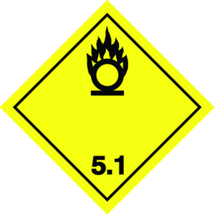 | 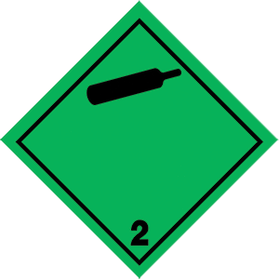 |  |  | 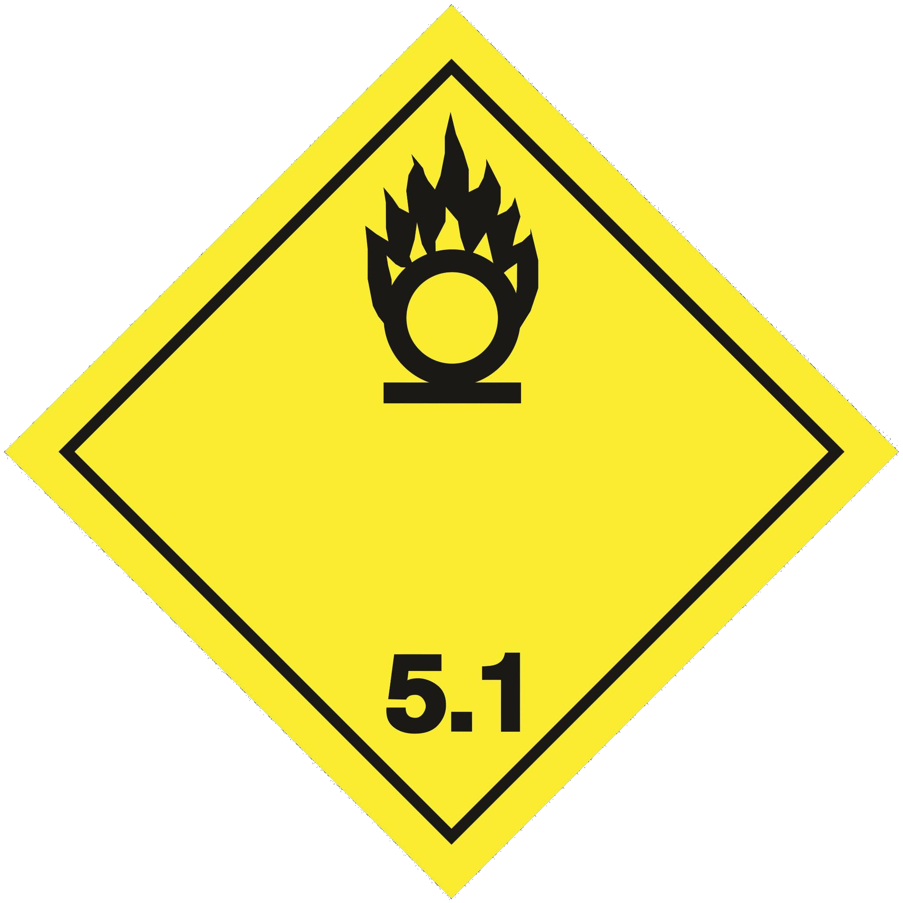
14.4. Packing group
Not applicable | Not applicable | Not applicable | Not applicable | Not applicable

ADR | IMDG | IATA | ADN | RID
14.5. Environmental hazards
Dangerous for the environment: No | Dangerous for the environment: No Marine pollutant: No | Dangerous for the environment: No | Dangerous for the environment: No | Dangerous for the environment: No
No supplementary information available
14.6. Special precautions for user
Special transport precautions : Avoid transport on vehicles where the load space is not separated from the driver's
compartment, Ensure vehicle driver is aware of the potential hazards of the load and knows what to do in the event of an accident or an emergency, Before transporting product containers: - Ensure there is adequate ventilation, - Ensure that containers are firmly secured, - Ensure valve is closed and not leaking, - Ensure valve outlet cap nut or plug (where provided) is correctly fitted, - Ensure valve protection device (where provided) is correctly fitted.

Overland transport
Classification code (ADR) : 1O
Special provisions (ADR) : 355, 655, 662
Limited quantities (ADR) : 0
Excepted quantities (ADR) : E0
Packing instructions (ADR) : P200
Mixed packing provisions (ADR) : MP9 Portable tank and bulk container instructions (ADR) : (M)
Tank code (ADR) : CxBN(M)
Tank special provisions (ADR) : TA4, TT9
Vehicle for tank carriage : AT
Transport category (ADR) : 3

Special provisions for carriage - Loading, unloading and handling (ADR)
: CV9, CV10, CV36

Hazard identification number (Kemler No.) : 25
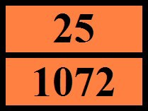
Orange plates :

Tunnel restriction code (ADR) : E
EAC code : 2S

Transport by sea
Special provisions (IMDG) : 355
Limited quantities (IMDG) : 0
Excepted quantities (IMDG) : E0
Packing instructions (IMDG) : P200
EmS-No. (Fire) : F-C
EmS-No. (Spillage) : S-W
Stowage category (IMDG) : A
Properties and observations (IMDG) : Non-flammable, odourless gas. Strong oxidizing agent. Heavier than air (1.1).

Air transport
PCA Excepted quantities (IATA) : E0
PCA Limited quantities (IATA) : FORBIDDEN PCA limited quantity max net quantity (IATA) : FORBIDDEN PCA packing instructions (IATA) : 200
PCA max net quantity (IATA) : 75kg
CAO packing instructions (IATA) : 200
CAO max net quantity (IATA) : 150kg
Special provisions (IATA) : A175, A302

ERG code (IATA) : 2X

Inland waterway transport
Classification code (ADN) : 1O
Special provisions (ADN) : 355, 655, 662
Limited quantities (ADN) : 0
Excepted quantities (ADN) : E0
Equipment required (ADN) : PP
Number of blue cones/lights (ADN) : 0

Rail transport
Classification code (RID) : 1O
Special provisions (RID) : 355, 655, 662
Limited quantities (RID) : 0
Excepted quantities (RID) : E0
Packing instructions (RID) : P200
Mixed packing provisions (RID) : MP9 Portable tank and bulk container instructions (RID) : (M)
Tank codes for RID tanks (RID) : CxBN(M)
Special provisions for RID tanks (RID) : TA4, TT9
Transport category (RID) : 3

Special provisions for carriage - Loading, unloading and handling (RID)
: CW9, CW10, CW36

Colis express (express parcels) (RID) : CE3
Hazard identification number (RID) : 25
14.7. Transport in bulk according to Annex II of Marpol and the IBC Code
IBC code : Not applicable.
SECTION 15: Regulatory information
15.1. Safety, health and environmental regulations/legislation specific for the substance or mixture

    - EU-Regulations
REACH Annex XVII (Restriction List) Not listed on REACH Annex XVII
REACH Annex XIV (Authorisation List)
Not listed on REACH Annex XIV (Authorisation List)
REACH Candidate List (SVHC)
Not listed on the REACH Candidate List
PIC Regulation (Prior Informed Consent)
Not listed on the PIC list (Regulation EU 649/2012)
POP Regulation (Persistent Organic Pollutants) Not listed on the POP list (Regulation EU 2019/1021)
Ozone Regulation (1005/2009)
Not listed on the Ozone Depletion list (Regulation EU 1005/2009)
VOC Directive (2004/42)
Restrictions on use : None.
Seveso Directive (Disaster Risk Reduction)
Seveso Directive : 2012/18/EU (Seveso III) : Listed.
Explosives Precursors Regulation (2019/1148)
Contains no substance(s) listed on the Explosives Precursors list (Regulation EU 2019/1148 on the marketing and use of explosives precursors)

Drug Precursors Regulation (273/2004)
Contains no substance(s) listed on the Drug Precursors list (Regulation EC 273/2004 on the manufacture and the placing on market of certain substances used in the illicit manufacture of narcotic drugs and psychotropic substances)
    - National regulations
Ensure all national/local regulations are observed.
Safety data sheet in accordance with commission regulation (EU) No 2020/878.
Council Directive 89/391/EEC on the introduction of measures to encourage improvements in the safety and health of workers at work Directive 2016/425/EEC on personal protective equipment
Directive 2014/34/EU on equipment and protective systems intended for use in potentially explosive atmospheres (ATEX)
Only products that comply with the food regulations (EC) No. 1333/2008 and (EU) No. 231/2012 and are labelled as such may be used as food additives. This Safety Data Sheet has been produced to comply with Regulation (EU) 2015/830.
United Kingdom
British National Regulations : Dangerous Substances and Explosive Atmospheres Regulations (DSEAR 2002 No. 2776).
Management of Health and Safety at Work Regulations (1999 No. 3242). The Regulatory Reform (Fire Safety) Order 2005 (2005 No. 1541).
Control of Substances Hazardous to Health Regulations (COSHH, 2002 No. 2677). Equipment and Protective Systems Intended for Use in Potentially Explosive Atmospheres Regulations (EPS, 1996 No. 192).
Provision and Use of Work Equipment Regulations (PUWER, 1998 No. 2306). Personal Protective Equipment Regulations (1992 No. 2966).
Control of Major Accident Hazards Regulations (COMAH, 2015 No. 483). Chemical Hazards Information and Packaging for Supply (CHIP, 1994 No. 3247). Pressure Systems Safety Regulations (PSSR, 2000 No. 128).
Only products that comply with the food regulations (EC) No. 1333/2008 and (EU) No. 231/2012 and are labelled as such may be used as food additives.
15.2. Chemical safety assessment
A CSA does not need to be carried out for this product.
SECTION 16: Other information
Indication of changes:
Safety data sheet in accordance with commission regulation (EU) No 2020/878.

Abbreviations and acronyms:
ADN | European Agreement concerning the International Carriage of Dangerous Goods by Inland Waterways
ADR | ADR - Agreement concerning the International Carriage of Dangerous Goods by Road
ATE | ATE - Acute Toxicity Estimate
BLV | Biological limit value
BOD | Biochemical oxygen demand (BOD)
CAO | Cargo Aircraft only / Cargo Aircraft only
CAS-No. | Chemical Abstract Service number
CLP | CLP - Classification Labelling Packaging Regulation; Regulation (EC) No 1272/2008
COD | Chemical oxygen demand (COD)
CSA | CSA - Chemical Safety Assessment
DMEL | Derived Minimal Effect level
DNEL | Derived-No Effect Level
EC50 | Median effective concentration
EC | European Inventory of Existing Commercial Chemical Substances

Abbreviations and acronyms:
ED | Endocrine disrupting properties
EINECS | EINECS - European Inventory of Existing Commercial Chemical Substances
EN | European Standard
IARC | International Agency for Research on Cancer
IATA | International Air Transport Association
IMDG | International Maritime Dangerous Goods
IOELV | Indicative Occupational Exposure Limit Value
LC50 | Median lethal concentration
LD50 | Median lethal dose
LOAEL | Lowest Observed Adverse Effect Level
NOAEC | No-Observed Adverse Effect Concentration
NOAEL | No-Observed Adverse Effect Level
NOEC | No-Observed Effect Concentration
N.O.S. | Not Otherwise Specified
OECD | Organisation for Economic Co-operation and Development
OEL | Occupational Exposure Limit
PBT | Persistent Bioaccumulative Toxic
PCA | Passenger and Cargo Aircraft / Passenger and Cargo Aircraft
PNEC | Predicted No-Effect Concentration
PPE | PPE - Personal Protection Equipment
REACH | Registration, Evaluation, Authorisation and Restriction of Chemicals Regulation (EC) No 1907/2006
RID | Regulations concerning the International Carriage of Dangerous Goods by Rail
RMM | RMM - Risk Management Measures
STP | Sewage treatment plant
ThOD | Theoretical oxygen demand (ThOD)
TLM | Median Tolerance Limit
TRGS | Technical Rules for Hazardous Substances
STOT-RE | Specific Target Organ Toxicity-Repeated Exposure
STOT-SE | Specific Target Organ Toxicity-Single Exposure
UFI | Unique Formula Identifier
UN | UN - United Nations
VOC | Volatile Organic Compounds
vPvB | Very Persistent and Very Bioaccumulative
WGK | Water Hazard Class

Training advice : Ensure operators understand the hazard of oxygen enrichment.
Other information : Classification in accordance with the procedures and calculation methods of Regulation (EC) 1272/2008 (CLP). Key literature references and sources of data are maintained in EIGA doc 169
: 'Classification and Labelling Guide', downloadable at http://www.Eiga.eu .

Full text of H- and EUH-statements:
H270 | May cause or intensify fire; oxidiser.
H280 | Contains gas under pressure; may explode if heated.
Ox. Gas 1 | Oxidising Gases, Category 1
Press. Gas (Comp.) | Gases under pressure : Compressed gas

The classification complies with : ATP 12
DISCLAIMER OF LIABILITY : Before using this product in any new process or experiment, a thorough material compatibility and safety study should be carried out.
Details given in this document are believed to be correct at the time of going to press.
Whilst proper care has been taken in the preparation of this document, no liability for injury or damage resulting from its use can be accepted.
Safety Data Sheet (SDS), EU GB
This information is based on our current knowledge and is intended to describe the product for the purposes of health, safety and environmental requirements only. It should not therefore be construed as guaranteeing any specific property of the product.

