

Setup info for IAP at Marksbury Road

# 

Contents

Location 3

Host mobile 3

Space Allocation 3

Call Handler room set up 4

Setting up the PC’s 4

1. Log on to bitwarden on the shift manager mobile 4

2. Switch to the Brisdoc PC 4

3. Log on to the PC 5

4. Open the Sesui phone system 5

5. Log in the phone handsets 5

6. Collect and connect the headsets 6

7. Open the clinical system 7

8. Answering & taking calls 7

9. Common issues 7

10. Closing Down at the end of the overnight 7

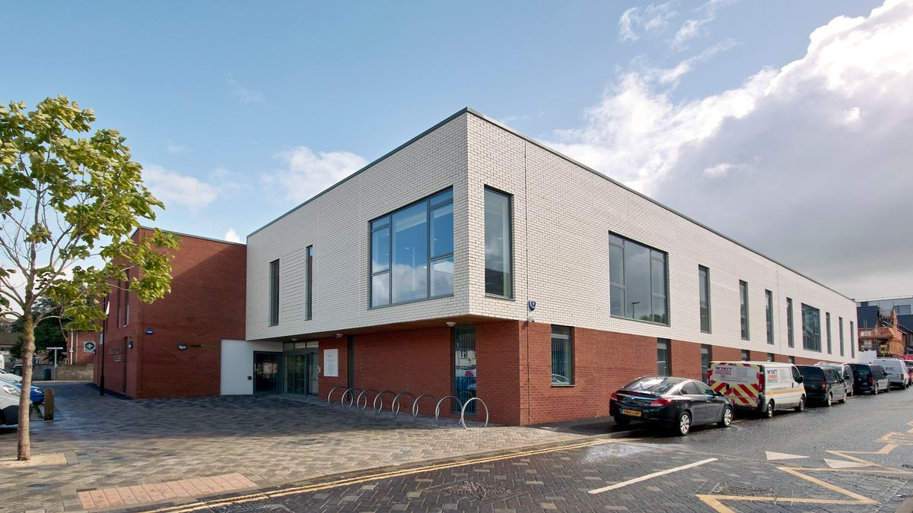This document is designed to aid the shift manager in the smooth management of the Mental health area at Marksbury rd.

## Location

Marksbury Road surgery,

Marksbury road,

Bedminster

Bristol

BS3 5JL

## Host mobile

Call the host on 0777 6306937 to gain access to the secure car park and building. There is a code for the back door to access the building, or you can call the Host.

# Space Allocation

On the Ground Floor we have use of the Call handler room which is between the large meeting room and the kitchen. If you come through the entrance from the patient car park, please take the door to the left by using the white fob which can be found in the outside keysafe next to the bin store. The code to the keysafe can be found on bitwarden.

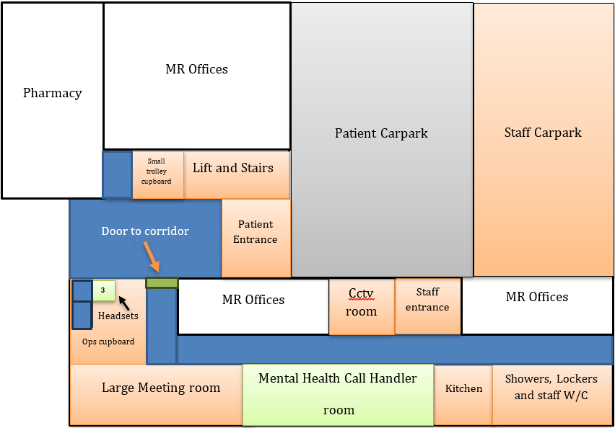

## Call Handler room set up

Within the call handler room we use the PCs on the 2 banks of desks on the right-hand side of the room as you walk in. (desks 10,11, 13, 14, 15, 16, 17, 18, 19, 20)

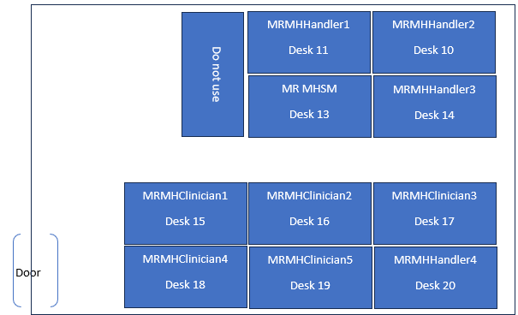

## Setting up the PC’s

1. Log on to bitwarden on the shift manager mobileEach shift manager will have to log into the bitwarden app on the shift manager mobile at the beginning of the shifts and log out at the end.

### Switch to the Brisdoc PC

We have our own separate PC’s at the Treatment Centre which are connected to the same monitors that the practice use. There is a Grey or black box next to each PC. This is the KVM and will allow you to switch between the SevernSide PC and the Marksbury Road PC by pressing the button. A blue light will come on when the corresponding PC is enabled. PC1 refers to the SevernSide PC, and PC2 refers to the Marksbury Road PC.

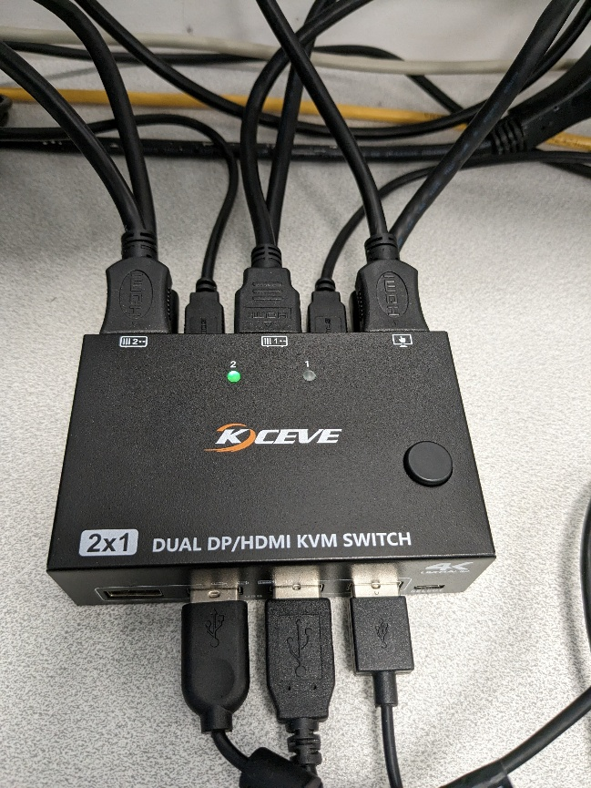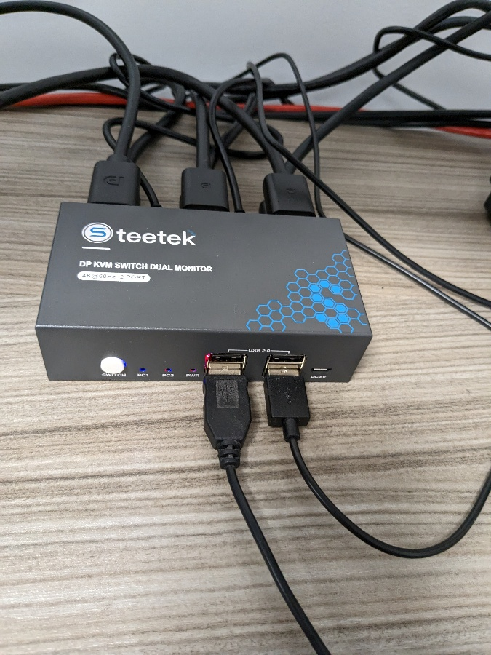For our shifts we need to ensure PC1 is lit up/active, and as part of the close-down process we need to ensure PC2 is lit up/active.

### Log on to the PC

Use the table above and log onto the PC using the username depending on the desk. The password is the same for all desks and can be found on Bitwarden under the IUC MH Sesui Operational section.

### Open the Sesui phone system

We aren’t able to use the Sesui app at Marksbury rd so sesui needs to be accessed via ‘SESUI Bases & Remote’ on the weblinks page as below:

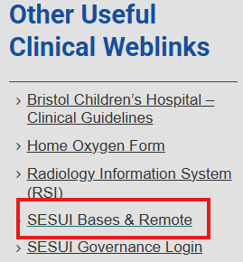

The sesui account for each desk can be found in the table above.

### Log in the phone handsets

The phone handsets need to be logged into the corresponding phone extension and sesui account. They can be found on Bitwarden for each desk.

1. The hand set will display a login screen when you get to it. If it doesn’t, hold down the back button until it resets to this. Enter the given Extension i.e 1618, select ok and then enter the same number as the password, again selecting ok   
   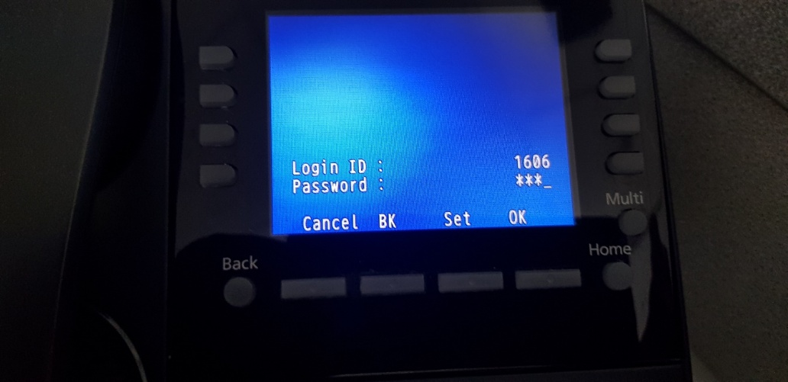
2. The Display will change to following display:   
   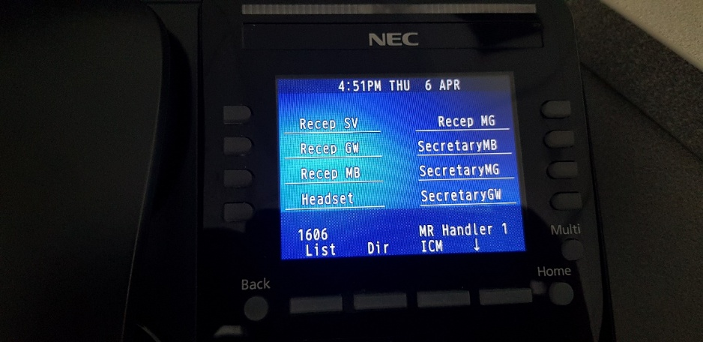
3. The phone is then ready to work
4. To log out press and hold the Back key until the screen changes to displaying the prompt asking are you sure you want to log out. Press the corresponding key to say Yes. You will then need to select exit, and this will take you back to the log in screen
5. Please note, actions on the phone take a few seconds. The handset screen will display a few different bits of information such as LLDP, connecting etc.. **This is normal behaviour please do not press any other buttons, unplug cables etc!**

**Please note, if in a business continuity event you need to dial out directly through the phones, you will need to press 9 first**

### Collect and connect the headsets

The calls come through to the phones and not PCs at Marksbury Road therefore we cannot use the USB headsets, the Marksbury Road Mental Health specific headsets must be used as they are the only one compatible with the phone handset. The headsets for the phones are locked away in the cupboard 3 which can be found in the physical health consumables cupboard, this is in the room next to the large meeting room. Please ask the host or driver in physical health to show you if you are unable to find it. There is a keysafe at the end of the grey cupboards which contains the keys to all three cupboards, cupboard 3 is the driver cupboard. The code for this can be found on bitwarden or from the physical health host.

The headset can be connected to the back of the phone as below:

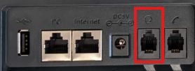

### Open the clinical system

Load the clinical system in the same way you would at Osprey court and log in

### Answering & taking calls

**Answering calls**

- Pluck the call, it will not ring directly to Marksbury Road. The phone handset will then ring

o If using the handset pick it up to answer

o If using the headset press the headset button on the phone

**Making calls**

- Dial the number in Sesui

- The phone will ring, answer by pressing the headset or answer button and this will then start the patients phone ringing (their phone does not ring until you have answered the call). If not using a headset just pick up the handset

- Press headset to hang up the call once complete

### Common issues

**Phones not working**

- Are you logged into Sesui via a web browser? We cannot use the app at MR

- Have you logged into the account and phones with the matching pins?

- Has the webpage closed with Sesui on?

**Can’t hear call**

- Are the handsets set to the headsets?

- Are the headsets muted?

- Is the PC volume muted?

### 10. Closing Down at the end of the overnight

* All our headsets to be replaced in the box and put back into the cupboard
* 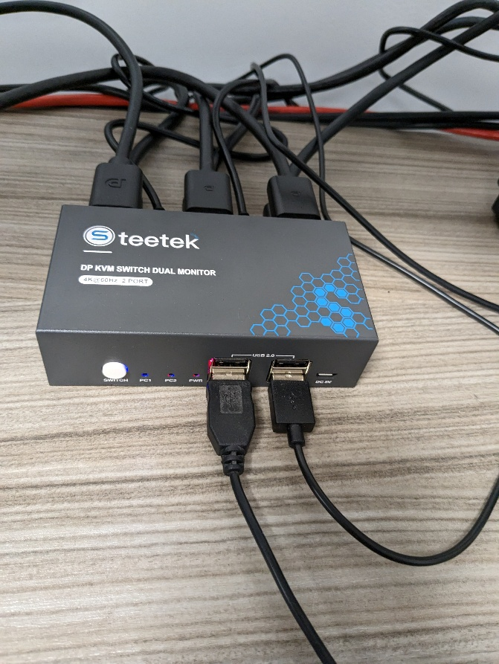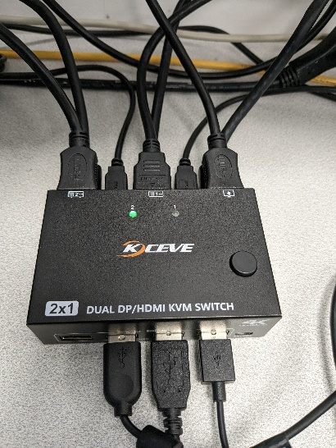Ensure computers are switched back to Marksbury Road PCs using the small switch box between PCs
* Log off phones by pressing ‘back’ on the handset
* Put the headsets back in cupboard 3 in the consumable’s cupboard, making sure keys are put back in the keysafe and the lock code is jumbled
* Ensure room is clear of any cups/plates rubbish
* Let physical health shift manager know you are leaving
* The swipe card should be replaced in the car park key safe when you leave at the end of the shift