Induction Confirmation

As part of the mandatory Corporate Induction, it is a requirement that you familiarise yourself with our Policies which can be found in the New Starter Hub on Radar.
It is particularly important that your read and confirm your understanding of the following policies:

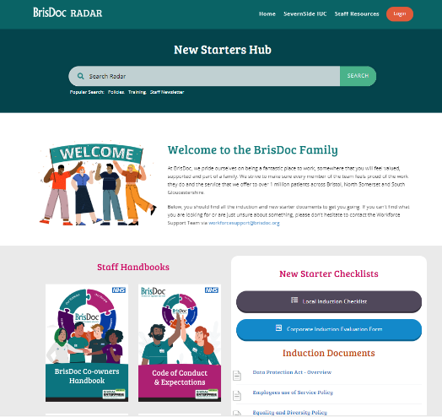
- Code of Conduct and Expectations
- Data Protection Act - Overview
- Employees Use of Service Policy
- Equality & Diversity Policy
- Health & Safety Policy
- Information Governance Staff Handbook
- Mobile Computing Good Practice Guide
- Payroll Process & Responsibilities
- Religious & Cultural Policy
- Safeguarding Children Policy
- Safeguarding Vulnerable Adults Policy

If you have any questions or queries about the content included here, please do not hesitate to contact the People Team on 0117 9370902 or 0117 937091 or workwithus@brisdoc.org
Please sign, date and return this confirmation to: workwithus@brisdoc.org to indicate that you have read and understood the aforementioned documents.

Name: ___________________________________________________________
Date: ___________________________________________________________
Role: ___________________________________________________________

I confirm that I have read and understood the documents as listed in the mandatory Corporate Induction training

