Severnside Sub-Management Meeting (PPGCMB)

Terms of Reference (TOR)

Version: | Owner: | Created:
2.0 | Deb Lowndes – Programme and Service Director | 28/07/2022
Published: | Approving Director: | Next Review
28/07/2022 | Deb Lowndes – Programme and Service Director | 28/07/2025

Contents

Purpose 3
Effectiveness Measures 3
Metrics 4
Arrangements for Chairing the Board 4
Membership 4
Quoracy for Decision Making 4
Frequency of Meetings 4
Exceptional Business 5
Accountability, Reporting and Relationships 5
Review 5
Version Control 5

Purpose
The purpose of the Practice Plus Group (PPG) Contract Management Board (PPGCMB) is to monitor and manage the subcontract of BrisDoc’s NHS Standard Contract for the provision of integrated urgent primary care services delivered to people in Bristol, North Somerset and South Gloucestershire. This will include the management of:
- Resource Care – income and expenditure
- Workforce Care – rota fill assurance
- Patient care - key performance indicators (KPIs)
- Quality Care - risks/Issues
The PPGCMB will hold PPG to account for the delivery of the sub-contract for the NHS 111 and Bridge elements of the Severnside Integrated urgent Care (SIUC) service.
The PPGCMB will uphold the principles of providing high quality patient and workforce care, within the available resource to the services, in accordance with BrisDoc’s corporate objectives and core values.
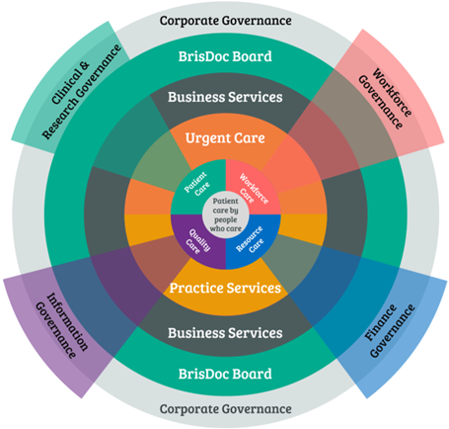

Effectiveness Measures
- To secure assurance of the effective and efficient delivery of the SIUC service
- To secure performance and contract sustainability and deliverability
- To effectively manage delivery of the sub-contract to the SIUC NHS Standard Contract
- To receive and agree plans that ensure there is no loss of income to the contracts through KPI penalties or failure to deliver CQUINs
- To receive and monitor remedial actions plans where there is sub-optimal delivery of objectives
- To receive and review exception reports
- On behalf of the SIUC Board ensure the SIUC contract is delivered with respect to quality, time and cost
- To agree corrective solutions for presentation to the SIUC Board

Metrics
The PPCMB will review the monthly contract performance and quality report and take a forward view on
- Workforce planning e.g., two-month rota fill
- Service costs, actual & forecast
- Activity, actual & forecast
- Service or platform change

Arrangements for Chairing the Board
The PPGCMB be chaired by BrisDoc’s Programme and Service Director. A deputy will be appointed in the absence of the Chair.

Membership
The core membership of the Group will be comprised of:
BrisDoc
- Programme and Service Director
- Head of Integrated Urgent Care
- Governance Manager
Practice Plus Group
- National Head of Practices, Out of Hours and Clinical Assessment Services
- IUC Contact Centre Manager - South West
- IUC Clinical Lead & Deputy Contact Centre Manager, RN, RM, Independent Prescriber
The Group will consult with external experts as necessary to secure effective performance management.

Quoracy for Decision Making
A meeting will be considered to be quorate when there is present at least the chair, and a manager representative from each of BrisDoc and PPG (including via video-consultation). If this is not possible decision making will proceed on the proviso that each organisation has been consulted on key decisions and that the Group representative for that organisation has submitted the views of the organisation concerned in advance. In exceptional circumstances if an organisational view cannot be submitted a decision may be deferred.

Frequency of Meetings
Meetings will be held monthly. A schedule of dates will be agreed on an annual basis so that members have the opportunity to prioritise the meetings accordingly in diaries.

Exceptional Business
In exceptional circumstances, for the purposes of urgent and/or important business that merits consideration and review by the PPGCMB between meetings, email/conference call communication will be used.

Accountability, Reporting and Relationships
The PPGCMB is accountable to the Integrated Urgent Care Leadership Oversight Board and will provide exception reporting to each as required.

Review
The TOR for the SQG will be reviewed annually.

Version Control
Version | Date | Author | Changes Overview
2 | 28.07.2022 | DL | General review and move onto new template

Agenda Template
Number | Item | Presenter
1. | Welcome and apologies for absence | Chair
2. | Performance Report | Head of IUC
3. | Rota and workforce review | Chair
4 | Compliance Update <Annual checks> | Chair
5 | Quality Assurance | Head of IUC
6 | Patient and Staff Experience 111 Feedback | Governance Manager
7 | Change | All
8 | Risk and Issues Management | Chair
9 | Notes and matters arising from the last meeting | Chair
10 | Date and time of the next meeting | All

