**Governance**

**Handbook**

|  |  |  |  |
| --- | --- | --- | --- |
| Content input by | Traci Clutterbuck  Sarah Pearce  Linda Meekhums | Quality Manager  Patient Safety Manager  Patient Safety Coordinator | September 2022 |
| Continual review |  |  |  |

**Contents**

1. Alerts Management 4

2. Audit Programme 4

3. Audit Southwest Annual Core Review 4

4. Care Quality Commission 5

5. Child Death Enquiries 6

6. Chronology Writing 7

7. Clinical Guardian Support 7

8. Contract Management 7

9. Corporate Dashboard Management 8

10. Complaints Management 9

11. Compliments Management 11

12. Equality Impact Assessments 11

13. Filming on BrisDoc Premises 12

14. Frequent user reviews 12

15. Healthcare professional feedback forms HPFF 13

16. Learning Event Management 13

17. Learning Event weekly figures 16

18. Insurance Renewals & database 17

19. ISO 9001 & 14001 17

20. Medicines Management Reports 17

21. Notifications 18

22. NPIS Query re use of TOXBASE 19

23. Patient Safety Culture Survey 21

24. Policy and Standard Operating Procedure Process (SOP) 22

25. PSQ process and analysis 23

26. Insurance Notifications 24

27. IUC Monthly / Quarterly Reports 26

28. PSQ Feedback Guidelines 26

29. QUALITY DATA SPREADSHEET 28

30. rapid case reviews 29

31. RIDDOR – Reporting of Injuries, Diseases and Dangerous Occurrences Regulations 29

32. Risk Register Review & Updates 30

33. Safeguarding Process 31

34. Severnside Quality Dashboard 34

35. Service Level Agreements 35

36. SEVERNSIDE GOVERNANCE TEAM / QUALITY GROUP 36

37. Tackling Violence 36

38. 38

|  |
| --- |
|  |

|  |
| --- |
| Alerts Management The BrisDoc Governance team receive national alerts from MHRA and NHSE via our [brisdoc.alerts@nhs.net](mailto:brisdoc.alerts@nhs.net) email account. If the alert is applicable to our service the contents of the alert should be disseminated to our Clinical or Operational colleagues. Our colleagues will share the knowledge contained in the alert with other team members or if the alert is about a stock of medication we may hold, the Facilities Team will manage its removal and destruction or its return to the manufacturer.  Process   * Open the [brisdoc.alerts@nhs.net](mailto:brisdoc.alerts@nhs.net) email account   Read the alert and if it is applicable to our service (check with facilities or a clinical lead if you are unsure)   * Complete the alerts spreadsheet with the relevant information S:\GOVERNANCE TEAM\ALERTS\2021'22\Clinical Alerts, MHRA alerts 2021'22.xlsx * Save a copy of the email in S:\GOVERNANCE TEAM\ALERTS folder * Save a copy of the actual alert in the S:\GOVERNANCE TEAM\ALERTS (it’s the PDF of the alert that you want to save) * Forward the alert to the correct team members (IUC - CD,FB,HC,LW,RR,AM,JM) (facilities team [facilities.brisdoc@nhs.net](mailto:facilities.brisdoc@nhs.net)) * Save the response from the “investigator” in the alerts folder (as auditable evidence of the review/actions etc.) * Complete the alerts spreadsheet with the findings/action taken etc. * Once fully actioned delete the email from the alerts email inbox   Note:  The alerts inbox also receives the weekly HSE newsletter, the NHS Resolutions newsletter and NICE newsletters. Theses emails need scanning for any relevant news/learning form BrisDoc and sharing accordingly. Audit Programme IUC should have an annual audit programme including clinical and operational audits. There is contractual requirement for there to be an annual safeguarding audit the learning from which should be included in the performance report.  The programme should be proposed by the Severnside Quality Group and approved by the Urgent Care Leadership and Operational Board. The SQG will monitor progress of the programme, receive and review audit reports and report learning and by exception to the LOB.  There is an audit plan template and audit report here: S:\GOVERNANCE TEAM\Audit Programme  Audit reports (or a summary) should be included in the Clinical Toolkit and learning cascaded through newsletters.  In addition, there is a corparte annual audit schedule which can be found in the Governance auit prograame folder. Audit Southwest Annual Core Review **BrisDoc is a member of Urgent Health UK.** This is a federation of Social Enterprise Unscheduled Primary and Community Care Providers. since 2018.  The core review is divided into two parts: Part A and Part B. Part A is completed first for all members, followed by Part B when the next core review is carried out  **Overall Aim**  The overall aim of the core review process is to aid members in improving their services through reviewing and assessing their internal systems and controls and, where appropriate, benchmarking performance. The review process provides assurance to the UHUK Executive and to individual member organisations that a range of appropriate systems and processes are in place, with agreed action plans established if any gaps in controls have been identified. The review is designed to cover all of the organisation’s services  **Approach**  In both Part A and Part B of the core review we will be assessing organisations in a range of individual areas that fall under seven ‘pillars’. Based on our findings, members will be assigned a score for each individual review area, a rating for each pillar and an overall review rating. As part of the review we will also be taking into account a range of factors such as:   * Background details about the organisation, to help put our findings into context (e.g. population served, services provided, number of commissioners, geographical area covered etc.). * The details and results of any external assessments and/or accreditations that we could potentially place reliance on. * Any local agreements in place with commissioners.   The date of the annual audit is agreed – This is usually around October or November. A few weeks prior to the audit the auditor from Audit Southwest (ASW) shares the latest versions of the following documents   * Terms of Reference (ToR) * Understanding the Organisation * Guide for UHUK members * Overview of review areas * Documents and Information required   The Governance team member managing the audit will share the ToR with the service/clinical leads and key managers along with a link to the ‘prior audit documents and information required’ spreadsheet.  The completed ‘prior audit document’ pack is shared with the auditor by the agreed date  Once the auditor has the document pack, they will request further documentary evidence and a schedule of interviews with auditor nominated individuals  The auditor will continue to request further documents and/or interviews as the audit progresses  Once the audit is complete the auditor will share their initial findings and BrisDoc will have an opportunity to challenge any proposed action plan.  Once the final audit report is received it is shared with Service/Clinical Leads.  Action plans are shared with individual service leads, these must be updated regularly and returned to ASW. Care Quality Commission Melanie Hutton is BrisDoc’s Relationship Manager (Inspector) in CQC. Melanie will hold 1/4ly engagement meetings with BrisDoc’s CQC lead to which Registered Managers can be invited. She wants to know what has changed for the organisation, it’s an opportunity to share with her and learn from her intelligence about what is happening in the system and what we can learn from.  S:\GOVERNANCE TEAM\CONFIDENTIAL\CQC holds the governance CQC info because there are forms for the registered manages which contain their personal information.  S:\GOVERNANCE TEAM\CONFIDENTIAL\CQC\Registration\ORGANISATION REGISTRATION holds the spreadsheet that includes all our relevant contact details and registration numbers.  The Statement of Purpose (latest version is number 21) sets out the purpose of our business, the services we provide and the activities we are regulated for by CQC. It is an audit trail of all changes made to our regulated services. Child Death Enquiries The death of any child in BNSSG is reviewed, even if it is expected due to a known life limiting condition.  The Child Death Enquiries Office (CDEO) is based in St Michael’s Hospital.  Child Death Enquiries Office  Level D  St Michael's Hospital  Southwell Street  Bristol  BS2 8EG  Tel: 0117 342 5277  Lara Cross, Paediatric Information Assistant is our key contact. [Lara.cross@nhs.net](mailto:Lara.cross@nhs.net)  Process  Lara sends an email to [Severnside.governance@nhs.net](mailto:Severnside.governance@nhs.net) seeking information about any Severnside consultation with the child (or associated family members if appropriate).  Nicholson House Patient Experience Team check for 111 consultations and respond with date/time to [Severnside.governance@nhs.net](mailto:Severnside.governance@nhs.net).  BrisDoc governance team check for CAS/F2F consultations and respond to [Severnside.governance@nhs.net](mailto:Severnside.governance@nhs.net).  A Severnside response is sent to Lara by the Head of Governance.  Where there has been no contact save a copy of the reply to Lara in: s/governanceteam/confidentialDAC/Informationrequests/relevant year/CDEO.  Where there has been a contact:   * create an information request folder and save the response there with a copy of the case record, voice recordings etc. * Record this info request on the IR database. * Ask Lara for more information about the death * Ask 111 for the details of their contact * Check if there are any associated LERIS/BOB events * Share death with clinician’s line manager so case can be reviewed if necessary * Save any clinician reflection/learning in the folder   Child Death Review  A CDR meeting will be held for which Severnside will be asked to complete a report and attend the meeting if there had been contact with the child. The request is sent to [sarah.pearce3@nhs.net](mailto:sarah.pearce3@nhs.net) (usually by Lara) that includes a link to the online form.  The online form is completed with the information provided for any 111 contact and from the case record etc. The information is a factual record of the chronology of the contact and contents of the case record.  On completion of the form take a copy and save in the info request folder.  Access to the online form is by named users only.  When a CDR meeting date is set Sarah Pearce will be notified and attendance will be confirmed from Severnside. It is a sharing and learning opportunity and should be written up by whoever attends for feeding back. PPG and BrisDoc should be represented where there was both 111 and CAS/F2F contact. PPG or BrisDoc may attend if contact was only 111 or CAS/F2F respectively.  Attendance and any immediate learning should be reported to the Severnside Quality Group.  The Child Death Review Co-ordinators are Sarah Fowler and Paula Lane [childdeathreviewcoordinatorsW&C@uhbw.nhs.uk](mailto:childdeathreviewcoordinatorsW&C@uhbw.nhs.uk) (note not nhs.net account) 0117 342 7441 Chronology Writing BrisDoc may be asked to provide a chronology for a partner organisation – typically in relation to a safeguarding case review.  The request will usually come from the Local Authority safeguarding team relevant to where the patient lives/d and be accompanied by a template to complete. Sometimes the request for information comes from the CCG Safeguarding Leads.  A chronology is a date/time account of what took place, where and by whom for the patient.  The investigations being undertaken may be a rapid review (RR), safeguarding adults review (SAR), child safeguarding practice review (CSPR), serious case review (SCR), domestic homicide review (DHR).  The request for information should be included in the IR database and a folder set up. Clinical Guardian Support The Clinical Guardian Team is a team of clinicians who perform audits on IUC cases to support the effective clinical audit of treatment and advice provided to patients by IUC. Effective audit will assure BrisDoc of the clinical safety and efficacy of the care provided by its clinicians, and support Clinicians through learning and development.  The Clinical Guardian Team meet every two weeks on a Friday morning. Admin support is provided by the Governance Team in the form of:  Room booking  The Ashton Room is booked out as a recurring meeting by the Governance Team. If schedules change or additional meetings are needed, the CG Team will request the booking is amended.  Call recordings  Telephone calls are reviewed as part of the audit process, the CG team will routinely provide the names of clinicians and request a sample of three of their calls for review. Contract Management Contract Types  NHS Standard Contract (including a sub-contract) is used for all hospital, mental health, community and NHS 111 (and therefore by default IUC services).  <https://www.england.nhs.uk/nhs-standard-contract/>  The NHS Contract is made up of sections on Service Conditions, General Conditions, and Particulars. The contract is updated annually by NHSE and a variation issued by the commissioner rather than reproduce a new contract each year. Variations are negotiable and should be issued for any change made to the contracted service e.g. additional income to deliver the NHS 111 first programme. The timetable for finalising the new national contract always over-runs however, drafts for consultation are issued with proposed changes tracked so preparation can be made for changes and therefore variations.  The CCG contracts with BrisDoc for the IUC service i.e. we are the prime contractor holding the NHS Standard Contract for Integrated Urgent Care Services. This service includes NHS 111 which BrisDoc sub-contracts to PPG. As prime contractor BrisDoc issues a sub-contract to PPG, manages that contract and is responsible for the performance of the NHS 111 service.  The contract includes performance and quality indicators relevant to the service. These have to be reported on to the commissioner and discussed at contract meetings.  The IUC service includes services delivered by GPs (i.e. the old OOHs service) which means the contract must include Schedule 2l. Schedule 2l includes the equivalent contractual requirements as an APMS contract.  General Medical Services (GMS), Primary Medical Services (PMS), Alternative Provider Medical Services (APMS) contracts are used for GP surgeries.  <https://www.england.nhs.uk/gp/investment/gp-contract/>  BMC/HHS/CKMP have APMS contracts because of the way they were commissioned – BMC was set up as an equitable access service, HHS is not a typical GP surgery but a service and CKMP was tendered through the short-term contract framework because the GP Partners resigned their contract with the CCG. A GMS contract is held where a partnership of GP own and manage their surgery. PMS contracts are also a partnership model that attracted more income for doing more for the patients. These are no longer issued and the income is gradually being aligned with that received under a GMS contract.  The BMC contract initially attracted an enhanced fixed income that has now been aligned to the GMS contract model i.e based on list size and quality performance.  Contracts held by BrisDoc are saved here.  S:\GOVERNANCE TEAM\Corporate\Contracts Corporate Dashboard Management Data sources  Practice Services activity – send practice services page to Josh Hastings in BMC at the beginning of each month and he will provide the data to be included. [Joshuahastings@nhs.net](mailto:Joshuahastings@nhs.net)  Workforce data, wellbeing data and IUC activity is provided by Howard.  Learning Event, complaint, compliment, patient experience, risk, IG and patient E&D data entered by Governance Team from our databases.  Compliance – policy data is input by Governance Team. Payroll errors data is provided by Kelly and entered by Governance Team.  Stock Management and ISO 14001 pages managed by Facilities Team. Governance Team take fossil fuel data from invoices saved here - S:\FACILITIES & BASES\12 INVOICING\OSPREY & OOH\BRITISH GAS\2021. Kyocera data taken from Debs’ invoices by Governance Team.  Finance data is input by Hani. Complaints Management What is a complaint?  A complaint is an expression of dissatisfaction about an act, omission or decision of BrisDoc, either verbal or written, and whether justified or not, which requires a response. A few examples of complaints expressed are:   * Something which is against the choice or wishes of a patient * The way treatment, service or care has been provided to a patient * Discrimination against a patient * How a service has been managed * Lack of a particular service * The attitude or other behaviour of staff   Serious Complaints  If a complaint is an allegation or suspicion of any of the following, it should immediately be investigated as a formal complaint:   * Physical abuse * Sexual abuse * Financial misconduct * Criminal offence   **In a situation where a person discloses physical/sexual abuse or financial misconduct, it must be reported as a Safeguarding concern, even if the person does not want to make a complaint.** Confidentiality should be maintained in such a way that only the managers and staff who are leading the investigation know the contents of the case. Anyone disclosing confidential/sensitive information to others who is not directly involved in the case should be dealt with under BrisDoc’s disciplinary procedure.  Any complaint, whether informal or formal, may not be straightforward and may lead to one or more of these apart from the complaints procedure:   * Disciplinary procedure * Reporting to the Police * Claims process * Investigation into sexual harassment * Grievance procedure   If BrisDoc is aware of a significant complaint or event (that is one where death or permanent injury occurred), the relevant Clinical Commissioning Group and the Commissioning Support Unit may be informed at the beginning of the next working day depending on the severity of the issue.  **The process of recording a complaint is as follows**  The notification of complaint (by email/nhs111/writing/telephone call/shift report) is received  Open the complaints spreadsheet (BOB) and begin to record the details    Open a new folder named BOB(the number assigned) in the relevant years complaint folder  S\GOVERNANCE TEAM\CONFIDENTIAL – DAC\COMPLAINTS\2021’22 Work\Severnside  Speak/Make contact with the patient or the patients’ representative (if the patient is not the complainant a 3rd party consent form may be required)  Document the points that the complainant would like us to investigate  Save a copy of the voice recording in the BOB folder  Open Adastra and obtain a copy of the case record/records  Access the relevant voice recorder and add copies of the clinical or operational telephone calls to the complaint folder  Update BOB with any further information  Add the details of the complaint to the complaints tracking spreadsheet    Email the new complaint (BOB number, Adastra case number, brief description of complaint, names of clinicians, and operational staff) to Clinical Leads and/or Service Delivery Manager  Acknowledge the complaint and share a copy of our complaints leaflet and a 3rd party consent form if required    Complaints must be responded to within 33 calendar days from receipt.  The response can be verbal or in writing depending on what the complainant requires.  Response letters are generally written by clinical or operational leads although, a number of complaints are closed down verbally either by a service/clinical lead or a member of the governance team (manage the patient’s expectation).    If response is shared verbally ensure a copy of the voice recording is saved in the complaints folder  When the response has been shared with the complainant the BOB entry can be updated and marked as closed.  The response tracking document should be updated and then the complaint (BOB) folder should be moved into the CLOSED folder. Compliments Management The process of recording a compliment is as follows  The compliment (by email/nhs111/writing/telephone call/shift report) is received  Open BOB and begin to record the details    Open a new folder named BOB(& the number assigned) in the relevant years compliment folder  S\GOVERNANCE TEAM\CONFIDENTIAL – DAC\COMPLIMENTS\2021’22  Open Adastra and obtain a copy of the case record/records  Access the relevant voice recorder and add copies of the clinical or operational telephone calls to the compliment folder  Update BOB with any further information  Email the new compliment (BOB number, Adastra case number, brief description of compliment, names of clinicians, and operational staff) to Clinical Leads and/or Service Delivery Manager and ask them to share the compliment with the staff involved  When the compliment has been shared with everyone mentioned and the email exchanges have been filed as evidence the BOB folder is complete Equality Impact Assessments S:\GOVERNANCE TEAM\Equality Impact Assessment  An equality impact assessment (EIA) is a process designed to ensure that a policy, project or scheme does not unlawfully discriminate against any protected characteristic.  Completion of an EIA screening matrix is intended to identify if the implementation of a new scheme (procedure, project, policy etc.) being introduced by BrisDoc might adversely affect someone with a protected characteristic and/or risk BrisDoc breaching its Public Sector Equality Duty or fail to comply with the Equality Delivery System.  Key criteria should be considered against each protected characteristic and if the implementation of the policy, project etc. would cause, or would have the potential to cause, an adverse impact on the person a full equality impact assessment should be undertaken.  An EIA should be completed by the key document author and attached to the key document when submitted for consideration and approval.  Screening matrix 1 takes into account specific areas for consideration against the protected characteristics e.g. the environment, physical access, communication, human rights when introducing a new scheme/project.  Screening matrix 2 focuses on the impact a new policy/guidance might have on someone with a protected characteristic.  An adverse response at screening level should generate a fuller assessment.  The CCG has an EIA tool it uses for system wide service changes the design of which may be used as the format for a fuller assessment. There are also template full assessments available on the internet. Filming on BrisDoc Premises There are occasions when a BrisDoc service or staff member is contacted about being filmed at work. This may be for a news item or a documentary type programme. Filming for news items is typically requested for a “same day” or “next day” basis. Often requests come via the Communications Team in CCG.  Requests for filming should be approved by a director. If not via the CCG it is sensible to let the CCG know as they provide BrisDoc’s professional Comms Support when needed.  The key requirements of the film crew before they can set foot on site are the following:   * Their risk assessment for filming at this location (typically this may include covid/IPC management, hazard management of associated props e.g. trailing wires, maintaining confidentiality) * A copy of their company’s public liability insurance certificate * If patients are to be involved a copy of their information for patients and consent form to participate * Signed third party confidentiality agreement (S:\IM&T\Information Governance (IGMS) 2021\Supporting IGMS Information\3rd Party Confidentiality Agreements\1. MASTER TEMPLATE\MASTER TEMPLATE)   We have to notify our public liability insurer that a film crew will be working in our premises (including outside areas). Send to Jo Wheldon at Perry Appleton a description of the project, the risk assessment and liability insurance certificate. Ideally the insurer’s approval is received before filming starts but this isn’t a deal breaker.  You need to assure yourself that the film crew is working with integrity. They could push the need for a deadline over providing their risk assessment. They all know a risk assessment has to be done so the bottom line is always “until we have the required paperwork they are not allowed onto our premises or to work with our clinicians”.  Keep a folder of the saved paperwork and emails for each episode of filming. Frequent user reviews Overview  Healthcare resources are finite and will become even more stretched as the population lives longer with increasing number of long-term conditions and increasing levels of ill-health and disability. One impact of this is constraint in primary care capacity and appointments in hours with the consequence that people look for alternative ways of accessing a primary care service. This may be at an A&E department, a minor injury unit, or a GP Out of Hours service. None of these alternatives are geared to providing a comprehensive primary care service provided by a GP practice.  All providers of healthcare services will need to work together to maximise the use of available resources and to ensure services are delivered efficiently and effectively for individual patients across the interfaces of in and out of hours, and primary and secondary care.  In order to support patients access the service most appropriate to their needs GP Practices need to be aware of and understand the number of attendances their patients have during out of hours periods within defined timescales.  In order to be supportive of the patient's usual GP Out of Hours clinicians need to provide treatment and advice that is consistent with care plans agreed between individual patients and their usual primary and community clinicians. These care plans may comprise a Care Programme Approach (CPA) for mental ill-health, a long term condition self-management plan, a Learning Disability care plan, or an advance care plan for end of life care.  **Frequent callers are those who have contacted the GP Out of Hours service 4 or more times in a 28 day period.**  Roles and Responsibilities  Information Analyst  Runs the Adastra monthly Frequent Callers by Surgery report(excluding palliative care/deaths),in the first week of each month for the previous month and for the 4 week period spanning the end and beginning of the 2 consecutive previous months.  SIUC Deputy Head of Nursing  Reviews patient list and advises on exclusions.  Supports practices with sharing care plans via the Special Patient Notes function in Adastra.  Supports practices in developing or revising care plans where indicated.  Monitor the effective use by BrisDoc clinicians of care plans.  SIUC Deputy Head of Nursing  By the end of the first week of each month, after the SIUC Deputy Head of Nursing’s review, sends a letter, document name – Master – frequent callers letter to Practice v3, to the Practice Manager providing the NHS number and number of attendances for relevant patients for that Practice. Healthcare professional feedback forms HPFF Severnside has created a HPFF to allow health care professionals to report concerns or learning opportunities. The form is also used between PPG and BrisDoc to pass cases for investigation between each part of the service.  The form is Severnside branded and contains the Severnside email address for return. Once received into the inbox, the relevant side of the organisation will pick up and manage through the process. Occasionally HCFF’s are received which need to be jointly managed across the service.  **Template forms can be found:**  S:\GOVERNANCE TEAM\CONFIDENTIAL - DAC\LEARNING EVENTS\SevernSide Integrated Urgent Care Health Professional Feedback Form v2.docx  Any healthcare professional (outside of the organisation) should be directed to this form. Once received into the joint Severnside inbox, the lead investigator will be decided (PPG or BrisDoc) then logged and managed following organisations internal process. Learning Event Management BrisDoc encourages the reporting and management of Learning Events as a constructive way to reduce risk and learn from and remedy issues, processes, and behaviours quickly and positively. Thereby maintaining a safe and effective working and care environment for all.  Internal Learning Events should always be reported through the online Learning Event portal; links to the portal can be found on the BrisDoc Weblinks page or Clinical Toolkit:  [Learning Event Report (brisdoc.co.uk)](https://incident.brisdoc.co.uk/)  When a Learning Event is reported through the portal an automatic email containing all the necessary information will be generated and sent to the BrisDoc Governance inbox.  On occasions, Learning Events are highlighted through other channels such as an email or shift reports. Learning Events from third parties will usually be reported via an email or telephone conversation.  Any form of Learning Event report will be excepted although staff will usually be directed to the portal to ensure they are aware of the process for future use.  All Learning Events need to be logged onto the Learning Event Reporting Information System (LERIS) found on the shared drive.  S:\GOVERNANCE TEAM\2. LERIS\LERIS 2020 LIVE VERSION 1.xlsx The file is password protected.  Upon receipt of an event report, The Governance Team will record on LERIS for the following events:   * Learning Events / near misses * Serious Learning Events * Safeguarding concerns * Health Care Professional Feedback   Step by step process:   1. Open the Learning Event report form and copy all the text in column B from row 3 to row 23 2. Open LERIS and paste the copied text into column C * you will need to select the transpose paste option by right clicking to paste the text across the columns rather than down the rows. The copied data will populate columns A to W     Right click to get drop down paste options and select ‘transpose’.   1. You will need to manually complete the following columns: X,Y,Z,AA,AB,AC,AE and AF 2. The following columns only need to be completed if applicable: AD,AG,AH,AI,AO AR-AV. Some columns be completed as the Learning Event investigation progresses. 3. Columns AJ and AP will need completing when closing down an Learning Event, the remaining columns will be auto populated. 4. Colum AQ auto populates to indicate if feedback has been given the reporter of the Learning Event. When closing down an Learning Event, if this column states ‘no’ then feedback has not been given (but has been requested), check that feedback has been issued and change to ‘yes’. If feedback has not been given, please refer back to the Learning Event manager for this to be actioned **before** closing down the Learning Event. 5. After a manager has been selected (column AC) an automatic reference number will be generated. 6. Set up a folder in the shared drive (in the relevant service folder) using the Learning Event reference number and a very brief indication of the issue i.e.: ‘Broken Thermometer’ and the date of the Learning Event e.g.: SC1098 Broken Thermometer 21.08.21. Save a copy of the Learning Event form into the folder, named as the reference number.   Allocating Learning Events  All Learning Events need to be allocated to a Learning Event manager; this is done in several ways as agreed locally with individual Teams.  **IUC Operations Team** – initially select ‘awaiting Ops Manager’ in column AC and place a copy of the Learning Event folder in the Ops Team Learning Event Management folder: S:\OOH Learning Event Management\1.New Learning Events - awaiting allocation. The team will regularly monitor this folder and allocate the Learning Events between them. A confirmation email will be sent advising who the manager is, this need to be changed on LERIS in column AC.  **Nursing Team** – Learning Events involving Nursing or Allied Health Professionals need to be allocated to the staff members Line Manager, a list can be found: S:\GOVERNANCE TEAM\CONFIDENTIAL - DAC\Line Managers for IUC Nursing Staff.xlsx Select the appropriate Manger and record on LERIS on column AC. Send a copy of the Learning Event report form to the Manager and save a copy of the email in the Learning Event folder.  **GP related Learning Events** – Some judgement is needed when allocating GP related Learning Events. If the Learning Event is potentially serious, allocate to one of the Lead GP team. It is important to keep the workload even, to do this, look at the number of open Learning Events currently allocated to each lead and allocate evenly. Send the Learning Event report to the Manger you have selected and copy in the other leads .  **Facilities** – Place a copy of the folder on the Facilities Learning Event file: S:\FACILITIES & BASES\Facilities Learning Events\1. New Learning Events and send a copy to the Facilities Manager.  **Practice Services** – Practice Services related Learning Events are managed through GP Team net by Practice Managers and we do not routinely record them on LERIS. If an Learning Event report is received, send on to the Practice Manager and ask if they would like it recorded on LERIS.  **Low level Learning events**  Learning events are reported on a daily basis, some have valuable learning for teams whether that be the operational team, clinical, facilities or business wide and these are logged for full investigation.  During the weekly audits on the IUC bases that the Facilities team perform, there are regularly more lower risk learning events identified. These events are logged but closed straight away, they are added to the monthly reports that are produced for the operational and clinical team and discussed in meetings once a month. If there are themes around the types of events happening then these will be reviewed further and adequate action taken.  The main benefit of combining the lower risk events is to reduce the amount of email reminders being sent out to staff and to provide information of whether the events are “one offs” or an adequate risk which could lead to a change in procedure.  A spreadsheet will be emailed from facilities:   * Copy all the lines and columns across with information in. * In the SDRIVE click in **S:\GOVERNANCE TEAM\2. LERIS and open LERIS 2020 LIVE VERSION 1** * Paste the lower risk learning events underneath the last event logged starting from column C. Then input as usual with the dates, who’s logging the event and which service. * In column AC (Manager dealing with incident) please select BS Governance Discretion. * Select whether it is operational/clinical and add if we have a name of who was involved in column AG (Clinician/Staff 1) * Close with today’s date and add in outcome detail ‘Low level risk events being monitored monthly’ * Complete the risk score as per normal process. * Once this is complete, save the lower risk spreadsheet from Facilities in **S:\GOVERNANCE TEAM\CONFIDENTIAL - DAC\4. LEARNING EVENTS\2022'23 work\Lower risk Events** * Create a new folder naming it with the start and finish reference numbers from LERIS such as BC1001 – BC1004, save the spreadsheet within that folder with the week commencing date i.e., WC 25.04.22. Once saved you can delete the email from the Governance inbox.  Learning Event weekly figures |

The purpose of sending out weekly figures and Learning Event log will ensure all relevant staff are kept up to date with Learning Events within target, out of target and to ensure all Learning Events are addressed in a timely manner.

All Learning Events allocated to members of staff are investigated this will ensure they do not happen again and highlight if a process needs reviewing or an employee needs further training.

To update figures within LERIS and to ensure all Learning Events are addressed.

Every Wednesday this process needs to be done.

Operations Team have a meeting every Wednesday. Once all staff have completed any updates, you then need to move spreadsheet from S:\GOVERNANCE TEAM\2. LERIS\Weekly Learning Event log\Current log to S:\GOVERNANCE TEAM\2. LERIS\Weekly Learning Event log\Archive Governance team only and open file.

You then need to open LERIS spreadsheet S:\GOVERNANCE TEAM\2. LERIS Any updates in Weekly Learning Event Log needs to be transferred and entered onto LERIS Spreadsheet under tab called Learning Events, enter any updates in columns AR, AS, AT & AU labelled Update 1, 2, 3 or 4. Once completed save work in LERIS and keep spreadsheet open. Do the same with Weekly Learning Event Log, but save file and close.

**To obtain new weekly figures as follows: -**

1. Learning Event tab in LERIS - Filter to all open Learning Events Column AK

2. Then go to open tab - delete all information from row 2 down - (right click where rows selected to delete)

3. Back to Learning Event tab - select open Learning Events in top left corner (*see image 1 – refer to tab labelled instructions for open table within LERIS)

4. Go back to Learning Event tab select find & select - go to special, then select visible cells only & press ok.

5. Learning Event tab - select control and c for copy

6. Go to open tab select cell A2 and paste 123 information control (v).

7. then on named tab of open - click right and select move & copy and make sure you select new workbook and create a copy. A new workbook will be created.

8. Once above is done all information is now showing in a new workbook, save as in sdrive/governance/LERIS/weeklyLearning Eventlog and name Weekly Learning Event Log (with today’s date)

9. Lastly add a password (Image 5 in tab named Instructions for open table) - password should be Weeklylog21 (capital W).

*(refer to diagrams on tab within LERIS named instructions for open table)

# Insurance Renewals & database

Perry Appleton are BrisDoc’s broker for employers and public liability, motor, cyber, management liability, and personal accident insurance. Jo Wheldon is our contact. Policy renewal is on 30th June each year. Jo will initiate the renewal process in April.

The information that underpins each policy will need reviewing for changes e.g. the value of contents in our premises, organizational income and staff numbers.

Gallagher is BrisDoc’s broker for our medical malpractice cover that is not covered by CNSGP. Graham Letford is our contact person. Policy renewal is 1st may ach year. Graham will initiate the renewal process in February. The Key Risk Information (KRI) spreadsheet will need updating with the current profile if staff in each service by WTE and head count. Howard Maxwell provides this data using rotamaster data. Any income and activity changes need recording in the KRI also, as well as any descriptions to the service model that the insurer, CNA, need to know about in order for us to be covered for that activity.

All insurance information is saved here: S:\GOVERNANCE TEAM\Corporate\Insurance. His includes the notifications log and the details of all policies by insurer, policy number and cost etc.

Changes to service provision need notifying to the brokers as this may affect policy cover. If in doubt ring Jo/Graham to check.

Insurers need to know of an Learning Event that might result in a claim e.g. a disciplinary process that might result in employment tribunal.

# ISO 9001 & 14001

BrisDoc is accredited with ISO 9001 for having a Quality Management System and ISO 14001 for having an Environmental Management System. The accrediting organisation is QMS.

Our current certificates run until 2025 and we are audited annually, usually in August, against the standards to determine if we maintain our accreditation.

We are audited against our 9001 and 14001 manuals and need to provide evidence of compliance.

S:\GOVERNANCE TEAM\QMS

# Medicines Management Reports

The Medicines Management Group meet once a month on the second Thursday, a member of the Governance Team will join that meeting to discuss Learning Events and themes surrounding medicines management and prescription management.

Data is pulled a week before the meeting to produce the monthly report we use LERIS’s dashboard tab *(sdrive/governance/LERIS/LERIS2020 live version)* and filter to the two specific event categories and month. Example below which is added to the medicines management dashboard *(saved in sdrive/medicines management/ medicines management dashboard)*



The data is reviewed whilst producing the report to confirm if there are any themes or increases in certain types of Learning Events, this is logged on the meds management dashboard along with a breakdown of each Learning Event to base and very brief description of the issue. This is saved in the medicines management folder for review during the meeting.

# Notifications

There are a number of situations in which a notification is required. These include:

* Serious Learning Event where the CCG has to be informed for national reporting and a 72hr report provided
* clinician presence at the time of a death where CQC has to be notified
* accident at work that meets the RIDDOR categories that has to be reported to the HSE
* Instances where there is potential for a claim to be raised against our insurance/indemnity cover.

Any Learning Event that meets the NPSA criteria for being serious is notified to the CCG via [bnssg.steis@nhs.net](mailto:bnssg.steis@nhs.net). The CCG will ask for all the information they need to make an entry into STEIS on our behalf. The Learning Event is flagged in LERIS as an SI.

CQC are notified when a clinician is present at the time a patient dies. This may be done via logging into the portal or completing and submitting a notification form. A copy of the notification form is saved S:\GOVERNANCE TEAM\CONFIDENTIAL\CQC\Notifications. The case number is the unique identifier. Details of BrisDoc’s registration for the form are here: S:\GOVERNANCE TEAM\CONFIDENTIAL\CQC\Registration\ORGANISATION REGISTRATION (CQC numbers log).

A work-related accident that meets RIDDOR categories is reported to the HSE here [Reportable Learning Events - RIDDOR - HSE](https://www.hse.gov.uk/riddor/reportable-incidents.htm). A copy of the report form will be given to HR for the staff members HR file and saved in the relevant Learning Event/accident folder.

Potential clinical negligence claims are notified to NHS Resolution via their website <https://resolution.nhs.uk/scheme-documents/when-and-how-to-report-a-claim/>

Claims Helpline 0800 030 6798

[cnsgpnotification@resolution.nhs.uk](mailto:cnsgpnotification@resolution.nhs.uk)

Save all correspondence with NHSR in the relevant Learning Event or information request folder.

Talk to Gallagher to see if CNA wish to be notified of any potential for a medical negligence claim. If they do there is a master notification form here S:\GOVERNANCE TEAM\Corporate\Insurance

Other claims may relate to employee relations issues e.g. where a member of staff has gone through disciplinary processes. It is the Management Liability Policy that provides BrisDoc cover against employment tribunals or other business risks.

Notifications are made to rradar (the legal helpline/advice behind our policy) on 0800 955 6111 quoting policy number SS MLP 7063923. You will be given a reference number. Make a file note of the conversation, actions agreed etc. and save it in the relevant Learning Event folder.

Log all insurance notifications on the spreadsheet saved here: S:\GOVERNANCE TEAM\Corporate\Insurance

**All notifications are captured in the corporate dashboard in the risk management tab.**

# NPIS Query re use of TOXBASE

Open a new Information Request folder S:\GOVERNANCE TEAM\CONFIDENTIAL - DAC\Information Requests\2020'21

Create new folder name IR00.. NPIS (substance) (date)

Include the request on the IR database – in the above folder.

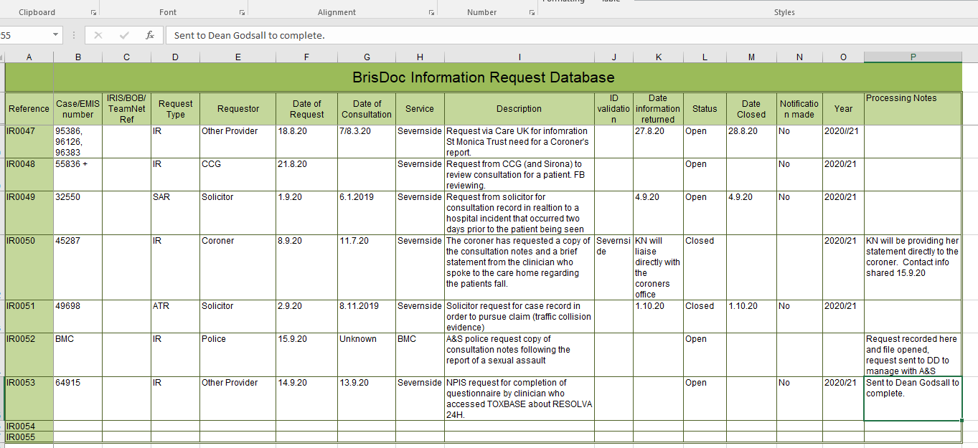

Run Adastra report for the date of the consultation using 1. IUC reports 2019/11. Full Report – 0419.

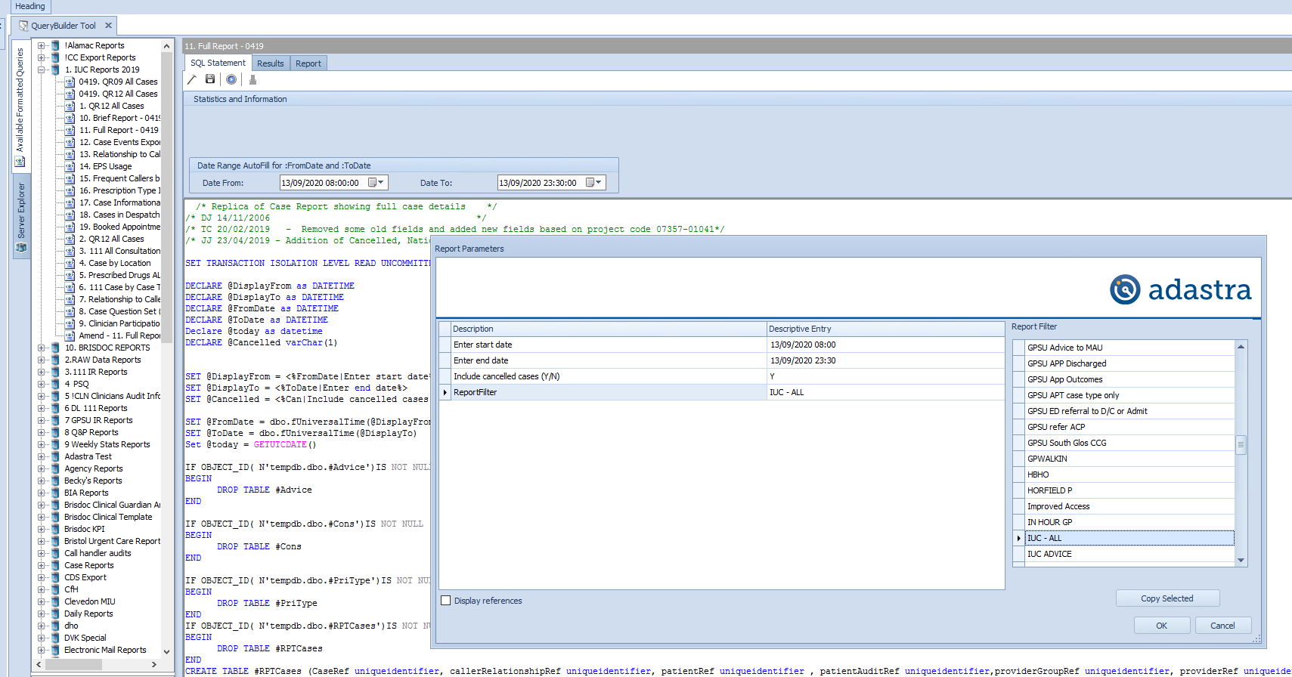

When report has completed running go to results tab, click excel icon and export spreadsheet saving it in the Information request folder. If you are asked about permissions then “allow” the permission.

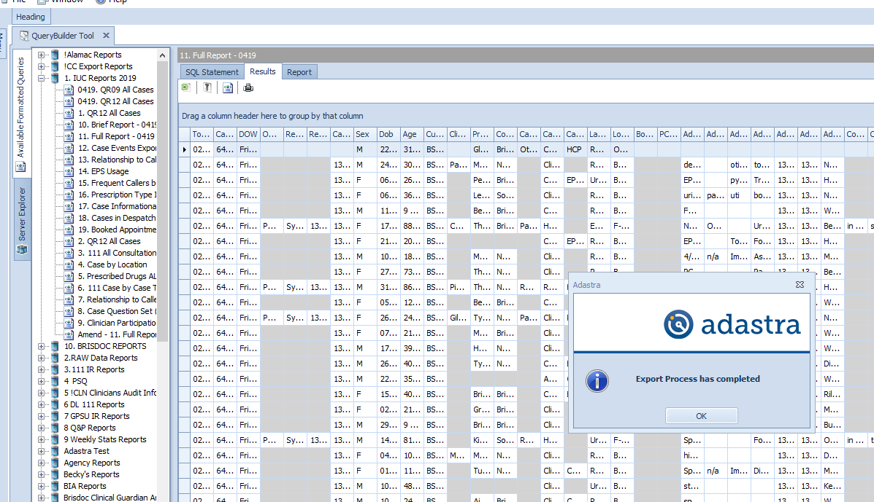

Open spreadsheet, sort by “advice began time” and find consultations around the time provided by NPIS in their letter. Review case tag column for any “poisoning” cases as these are the ones to start with. Read the consultation history and look for words – toxbase, the name of the poison in the NPIS letter.

If this doesn’t identify a case sort by “cons begin time” and repeat the process as TOXBASE could be used during a face to face consultation also.

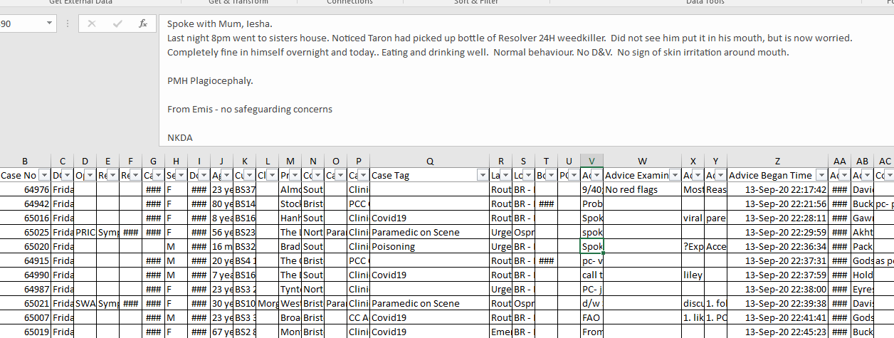

Take case number and write it on the NPIS letter. Scan a copy of the NPIS letter (no need to include the questionnaire) and send the master copy of the letter to the clinician with the request to complete the questionnaire and return it to the NPIS in the prepaid envelope they provide. Ask clinician to confirm to you when they have returned the questionnaire. I usually include a compliment slip “Dear …, I’d be grateful if you would complete this questionnaire for the NPIS please in relation to your consultation …..(case number) and let me know when you have returned. Many thanks …..”. The rota team will give you the clinicians postal address.

Delete the spreadsheet from the info request folder.

Close the IR when the clinician confirms they have returned the questionnaire.

# Patient Safety Culture Survey

In conjunction with Professor Mohammed A. Mohammed, Professor of Healthcare Quality and Effectiveness at the University of Bradford and Deputy Director of the Bradford Institute of Health Research, Urgent Health UK (UHUK) has developed a Patient Safety Culture Staff Survey.

The original survey, developed in 2014/15 to support Professor Mohammed’s research into organisational cultures in relation to patient safety, contained 72 questions. As part of his research, Professor Mohammed analysed the results from 2014/15 and created a revised, shortened survey containing 14 questions considered to be key to obtaining a good indication of patient safety culture. 2020 was the fifth year of running the survey in its current, revised form.

BrisDoc has commissioned an annual UHUK Patient Safety Culture Questionnaire, delivered by Audit South West who will contact us (most likely Nigel Gazzard) with a link to the survey when it is due.

A link to the Patient Safety Culture Survey is emailed via rotamaster to all our employees and self-employed GPs with a covering email from Dr Kathy Ryan (BrisDoc Medical Director). The Survey remains open for approximately 18 days and a reminder email from Kathy is sent on day ten.

Results are analysed by Audit South West and summarised into a report for us. The results provide a powerful, research validated tool which can inform us, that we have a culture of safety across our organisation which we are monitoring. Results are benchmarked against similar organisations; that data, along with data from previous years provides us with a starting point to make changes through, for example, focus groups or targeted work.

# **Policy and Standard Operating Procedure Process (SOP)**

To ensure BrisDoc Policy and SOP documents are kept up to date and fit for purpose, each document has a review date and an “owner”. This SOP will outline the role of a Policy or Standard Operating Procedure owner and the process they must follow.

Governance Team – will maintain an index of Policy and SOP documents, the team will track dates and highlight to Policy / SOP owners when a document needs reviewing. When the document has been reviewed and a final version is issued, the governance Team will update the index / shared drive and radar. The Governance Team are responsible for highlighting updated policies through the BrisDoc newsletter.

Policy or Standard Operating Procedure Owner – Responsible for ensuring the Policy is reviewed and updated, including documenting all changes in the change register. The owner of the document is responsible for liaising with any other contributors and combining changes as necessary. For policies – the owner should get approval for the policy changes from the appropriate governance group meeting (eg: Quality group or LOB) The owner is responsible for sending a complete final version of the document to the Governance Team. If delays occur in reviewing the document, the owner is responsible for communicating this to the Governance Team

When a policy or SOP has reached the review date, the following steps need to happen:

* The document will show as ‘red’ on the policy / sop index
* The Governance Team will highlight the document and the need for review to the document owner
* The document owner should review the document in conjunction with any relevant contributors and amend as needed.
* The document owner should maintain the change register
* The document owner should ensure all dates are updated (review date etc)
* For Policies, the owner should get approval from the most appropriate governance meeting.
* If there are delays in completing the review the document owner should flag this at the most appropriate governance meeting. And to the Governance Team to ensure the index is updated.
* When a final document has been agreed, the owner should send a word version to the Governance Team.
* The Governance Team will update the Policy / SOP index.
* The Governance Team will archive old versions and save the new version in the confidential policy folder on the shared drive.
* The Governance Team will replace the version on radar with a PDF version for general staff access.
* For SOPs – the owner should circulate a new version to the staff members who regularly use the document.

For Policies - The Governance Team will highlight in the newsletter that the policy has been reviewed and updated and encourage staff to familiarise themselves with the new

# PSQ process and analysis

1. Introduction

The purpose of this Standard Operating Procedure is to set out how to identify a random sample of qualifying patients to receive a Satisfaction Questionnaire. The SOP will also outline the process of printing and issuing the Questionnaire.

2. Objectives of the procedure

Sending out regular Patient Satisfaction Surveys (PSQ’s) help to monitor and evaluate how patients feel about the service they receive form BrisDoc (IUC SevernSide). Regular review meetings are held to evaluate the data taken form the responses.

3. The Standard Operating Procedure

Preparing Data

To get the sample of patients, every other Wednesday the task undertaker will use Adastra to:

* Reporting, Run User Report
* BrisDoc Reports, select QR05 PSQst report QR05 PSQ
* Amend dates to show the previous week, Wednesday – Wednesday
* Amend the sample percentage size to 5 %
* Select the filter PSQ
* Export the file as an excel spreadsheet to be saved in the folder: Save the spreadsheet in S:\GOVERNANCE TEAM\CONFIDENTIAL PSQ\ (relevant year) IUC PSQ\Data, and use date as the filename e.g., August 12-18

Open MASTER spreadsheet located: S:\GOVERNANCE TEAM\CONFIDENTIAL PSQ\ (relevant year) IUC PSQ and follow these steps:

* Select the ‘Paste new data here’ tab and delete all content
* Select HV tab and delete the **entire tab**
* Select ADVICE tab and delete **entire tab**
* Select PCC tab and delete **entire tab**
* Open the spreadsheet that you have just saved (Adastra results) and copy all data
* Go back to MASTER spreadsheet and paste the data in the tab ‘PASTE NEW DATA HERE’
* Select ‘REFRESH TABLE HERE Home Visit’ Tab and right click on the number in the grand total column – select ‘refresh’ – this will update the figures to reflect the new data pasted onto the first tab.
* Double click on the same number which will create a new sheet automatically called ‘sheet 1’ – rename HV
* Select ‘Clinician Advice’ tab and double click on the number in the ‘grand total’ column – this will automatically generate a new sheet called ‘sheet 2’ – rename this sheet ‘ADVICE’
* Select ‘Appointment’ tab and double click on the number in the ‘grand total’ column – this will automatically generate a new sheet called ‘sheet 3’ – rename this sheet ‘PCC’

Note that the naming of the sheets is very important as this will allow the mail merged document to link up to the correct sheet in the workbook automatically to produce letters.

Mail merging

* Open the letter template: ‘S:\GOVERNANCE TEAM\CONFIDENTIAL PSQ\2021-22 IUC PSQ\PSQ Letters\New 2019 - 2020 Versions 1. PCC PSQ’ and select ok to the command message that will appear
* Select mailings tab
* Click finish and merge button – then edit individual documents
* A merge to new document box will appear – select OK
* A message will appear advising of locked fields – select OK
* When the document merges, check the date at the top of the first letter is within the date range you selected for your original data
* Now ready to print
* After printing – there is no need to save the document, just make sure data has been copied into relevant month on PSQ results spreadsheet.

Printing

* Select the printer: Unit 21 Upstairs Kyocera TASKalfa 2551ci on BRISDOC-FS03.BrisDoc. local
* Select printer properties
* On the ‘BASICS’ tab – select colour and duplex to print double sided
* On the ‘finishing’ tab select the staple option by ticking the box on the staple diagram, this will automatically select the right position (top left) for the staple. Select 2 from the ‘sheets per group’ drop down menu
* On the ‘layout’ tab select make sure portrait?

Repeat mail merging and printing steps for the 2 other case types, Advice and Home visit.

Posting

Pass the letters to an Operations (NR) who will:

* Fold letters and envelope the Surveys using the labels provided
* Include a freepost envelope
* Frank and post 2nd class via Royal Mail (Franking Machine is located within Rota Team Office).

PSQ results

To maintain a spreadsheet of responses the Compliance Officer will Copy and paste the case numbers into the PSQ results spreadsheet for the relevant month. As questionnaires are returned enter the results for the relevant case.

Once the case numbers have been transferred the label list and questionnaires for that week can be saved under data.

# Insurance Notifications

BrisDoc is responsible for promptly notifying its medical professional liability insurer/CNSGP of claims and circumstances which may give rise to a claim under the policy. Failure to do so may result in a negligence claim not being covered by the policy. Such notice should include:

a. details of what happened and the services and activities that were being performing at the relevant time; and

b. the nature of any actual, or any possible, bodily injury; and

c. details of how BrisDoc first became aware of the claim or circumstance; and

d. all such further particulars as the insurer may require.

A “**circumstance**” is defined in the policy as:

*“any circumstances of which you become aware, or should reasonably have become aware, that may reasonably be expected to give rise to a Claim.”*

Examples of a circumstance are:

* Any complaint, written or verbal, in which the patient or patient’s representative expresses dissatisfaction regarding the treatment provided or a failure to provide and alleges that, as a result, the patient suffered bodily injury.
* A request for access to medical records received from a solicitor or third party on the basis that a Claim against you/your service (to include any of your employees) is being contemplated.
* Any Learning Event in which a Serious Learning Event Report is generated that involves potential or actual bodily injury
* Any unexpected or unusual death of which you become aware.
* Any adverse outcome or clinical “near miss” in which you believe there may have been a negligent act, error or omission, irrespective of whether or not the patient is aware of this or whether the patient or patient’s representative has made a complaint.
* An event that involves potential of actual bodily injury that triggers the threshold for the statutory duty of candour
* An accusation of abuse, including organisational abuse, levied by patients, families, local authority, commissioner or any other entity.
* A notification by the Parliamentary & Health Ombudsman that they may/intend to investigate an Learning Event or complaint.

It is recognised that complaints have the potential to escalate if not handled satisfactorily. The Insurer can provide expertise in assisting with responding appropriately to complaints. Collaborating with the Insurer can support complaint resolution at an early stage, thereby reducing the risk of litigation. Draft complaint responses may be sent to the Insurer prior to sending to the complainant. In complex complaints where harm was caused through mis-diagnosis or mis-treatment support should be sought from the Insurer.

When managing a complaint all statements, letters, phone calls and actions taken in an investigation must be documented, scanned and kept in the complaint folder for that individual on the BrisDoc shared drive as per CQC regulations and for clinical governance purposes. Where any documentation is sent to an external organisation it will be converted to pdf format before sending.

Complaint records will be kept for eight years following closure of any actions in accordance with BrisDoc’s Records Management Policy.

Each complaint will be entered into the BrisDoc Integrated Risk Management System BOB for Urgent Care and Business Services or in GPTeamNet for Practice Services. A comprehensive set of data will be entered into these databases so as to ensure BrisDoc can record response timescales; monitor progress with investigating complaints; capture learning outcomes and who has been involved; provide reports on complaint trends, categories etc. so as to support ongoing service improvement; and identify themes that may be a risk to the organisation.

How to make a notification to under the Clinical Negligence Scheme for General Practitioners (CNSGP) via NHS Resolutions This is the notification method for the majority of notifications received from 1st April 2019

Please click on the link below

<https://resolution.nhs.uk/wp-content/uploads/2020/03/ELSGP-Reporting-guidelines.pdf>

If the patient was cared for prior to April 2019, or the claim could be against BrisDoc and/or the clinician please use the link below.



Once the notification has been made to the indemnity provider please click the link below to add the details to the notification spreadsheet.



# IUC Monthly / Quarterly Reports

Each Month two separate reports are created by the Governance Team (using data pulled from LERIS) to summarise Learning Events reported through the previous month. The reports are separated and used as follows:

* Operational Learning Event report –Supplied to the quality lead Senior Team Manager to be used by the Ops team for discussion and review at their monthly quality meeting.
* Clinical Learning Event Report – Supplied to the Clinical Leads and Nurse Manager Team to be reviewed and discussed at the monthly clinical Learning Event meeting.

Each report will give a summary of the following areas:

* Number of Learning Events reported
* Breakdown of Learning Event categories
* Themes and /or trends
* Adherence to timescales for closing Learning Events
* Allocation split by Manager.

In addition, a Quarterly report is provided to the Ops Team to feed into the quarterly performance report.

# PSQ Feedback Guidelines

PSQ’s will arrive in a freepost envelope via Royal Mail.

Facilities will always put our post in the Governance in-tray.

To enter PSQ feedback, go to S:\GOVERNANCE TEAM\CONFIDENTIAL PSQ\2021-22 IUC PSQ

Password is scooby

Open letter, check date for example 16.06.2021 and enter PSQ feedback in June tab.

There will be a case number on letter, use that to search for case on spreadsheet. Ctrl F see diagrams below – this will help you to add information against correct case.

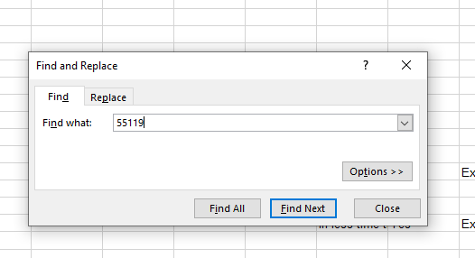

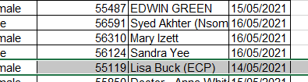

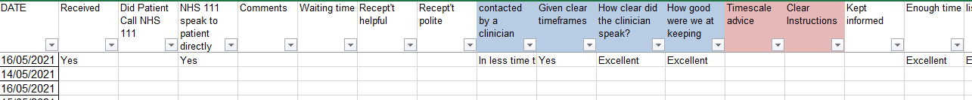

Add information along the row to question’s answered on the PSQ survey (letter). See above diagram and column heading.

Once completed save spreadsheet.

At the bottom of the spreadsheet there is statistics for all the entries that month. See diagram below.

This is just an example; all these figures link up to totals tab at end of spreadsheet which includes every month in the financial year 2021/2022. Nothing needs to be done with these figures, formulas/links have been sent at the beginning of financial year when a new spreadsheet was created.

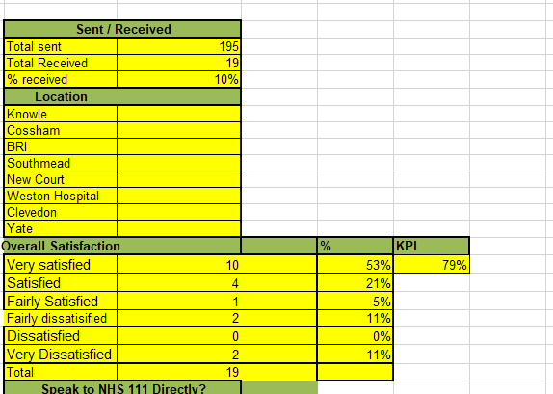

Once a month I check that statistics add up correctly on each tab.

Every two weeks when you print new PSQ’s to be sent to patients, you add statistics into first chart, making sure you split the categories, Advice, Base or Home.

# QUALITY DATA SPREADSHEET

The data and graphs held in the QualityData spreadsheet feed into the monthly/quarterly/6mth/yearly Quality and Performance Reports.

The data and charts in the QualityData spreadsheet need to be done and added to the Quality and Performance Report by the 14th of each month.

Quality and Performance reports can be found in "S:\GOVERNANCE TEAM\QUALITY AND PERFORMANCE MANAGEMENT\Q&P Reports\2021'22 " (or whichever year you happen to be in) and choose the month you are populating

The following tabs on the spreadsheet update the data contained within each tab

**FFT** (Monthly) data can be found in the Corporate Dashboard



Copy the data from the corporate dashboard and add it to the correct month on the qualitydata spreadsheet. The 3 graphs on the FFT tab should automatically update to include the monthly data you have just added. Copy and Paste these graphs into the Quality and Performance monthly report.

**Complaints (Monthly)** the data you are looking for can be found in the BOB spreadsheet 

Add the number of each type of complaint for the month in both tables, the graph should automatically update to include the monthly data you have just added. Copy and paste this graph into the Quality and Performance monthly report.

Add the SIUC complaint justified data this is also found in BOB. This information will need to be added to the Quality and Performance report, the quarterly graphs should be added on the quarter or 6-month report

**Compliments (Monthly)** the data you are looking for can be found in the BOB spreadsheet (see link above)

Add the number of compliments received to the table, the spreadsheet should automatically update to include the monthly data you have just added. Copy and paste this graph into the Quality and Performance monthly report.

**Clinical Effectiveness (Quarterly)** the data you are looking for can be extrapolated from reports that are run on the clinical guardian website

The reports you need to run for both **Severnside IUC and Weekday PL** are

* Reports/reports centre/Governance Team reports/**Audit by case type**

Add the from and to dates for the quarter you are running and run, download report and save the following categories

Hospital admissions, referred from BrisDoc to 999, referred from BrisDoc to 999

* Reports/reports centre/Governance Team reports/**List comments by audit type**

Add the from and to dates for the quarter you are running and run download report and save the following categories

Hospital admissions, referred from BrisDoc to 999, referred from BrisDoc to 999

* Reports/reports centre/For Commissioners/**Clinical Status Quality Report**

Add the interval Period (Quarter), check the dates of the period – clinical guardian has an annual quarter period rather than a financial quarter period. “All Audits” is the category you need. Update, download report and save.

The data you have obtained from the various reports above are added to the clinical effectiveness tab tables. Then these tables are added to the quarterly quality and performance report.

A selection of the comments are chosen from the Comments List report to show a balance of feedback shared to BrisDoc clinicians

**Training: Ignore this tab, the data is now automatically embedded into the report by the digital team**

**Language line (Quarterly)** the information in the language line tab is updated by the facilities team in time to be added as a table to the quarterly quality and performance report.

# rapid case reviews

These are convened, usually by one of the BNSSG Local Authorities, to review safeguarding needs, practices, service interfaces of vulnerable people, some of whom may have died.

If a BrisDoc service has been involved in the care of a vulnerable person a report will be requested by the convenor using a set template. The Governance Team will lead the completion of this report liaising with a clinician as required. Attendance at any meetings will be by the Governance team on behalf of the organisation, with the clinician if needed.

Learning from the case review will be shared accordingly.

# RIDDOR – Reporting of Injuries, Diseases and Dangerous Occurrences Regulations

RIDDOR is the Reporting of Injuries, Diseases and Dangerous Occurrences Regulations 1995. By law it is required for employers, as well as people who are self-employed and people who are in control of a premises, to report specified Learning Events in the workplace. These can include a wide range of things such as dangerous occurrences (when a serious accident was luckily avoided) all the way to work related deaths.

As an employer, it is a legal requirement to report all Learning Events, no matter how big or small, as well as ill health at work. In order to be legally compliant, a record must be kept of all Learning Events. Keeping RIDDOR records includes:

* Recording all reportable accidents, injuries, illnesses, dangerous occurrences, work-related deaths and specific injuries lasting more than seven days
* Keeping all records in a file, accident book, on a computer or a written log
* RIDDOR reporting is done through an online reporting system via the [HSE website](http://www.hse.gov.uk/riddor/report.htm)
* Understanding and patterns in injuries and/or accidents to be considered when undertaking risk assessments
* Keeping all records organised and up-to-date. In the event of a work-related claim, the insurance company will need to see your records – if they are not up-to-date or it is determined that there are Learning Events missing, this is against the law
* All employees’ RIDDOR records must be kept strictly confidential and are stored away securely. If the records are not kept confidential and stored properly, they will not be deemed compliant with the Data Protection Act

There are specific rules and regulations in regards to the Reporting of Injuries, Diseases and Dangerous Occurrences Regulations; aside from basic information such as keeping all records updated, the following is also important:

* A company with more than 10 employees must have an accident book
* Owners and/or occupiers of quarries, mines and factories must have an accident book
* RIDDOR records must be kept for a minimum of 3 years after the date of the last Learning Event in the book
* It is advised that RIDDOR records are kept for 5-6 years in order to allow time for any civil litigation to be made
* Learning Events must be reported within a 10-day timeframe after the occurrence

**What is the specific RIDDOR information I need to record?**

* The date of reporting
* The date, time and location of the Learning Event
* Personal details (name, job title etc) of the person(s) involved
* A description of the injury, illness or occurrence

What kind of Learning Events do I report in RIDDOR records?

* Work-related death
* Serious injuries
* Over-7-day injuries (where the person is unable to work for at least a week)
* Work-related diseases
* Injuries to members of the public (ie. not employees)
* Dangerous occurrences – when an accident *almost* happens
* Dangerous gas fittings in a workplace (Gas Safe registered gas fitters must report this)

A report must be received within 10 days of the Learning Event. For accidents resulting in the over-seven-day incapacitation of a worker, you must notify the enforcing authority within 15 days of the Learning Event, using the appropriate online form

To report an Learning Event go to <https://notifications.hse.gov.uk/riddorforms> click on the type of report you wish to make and complete the form

# Risk Register Review & Updates

The master version of the risk/issues register is “owned” by the Corporate Services Director (CSD). At the end of each quarter risk/issue owners will be asked to review their risk/issues and complete the update version of the register. The CSD will transfer all updates to the master register.

The registers are held here: S:\GOVERNANCE TEAM\RISK\RISK REGISTER\current

The Severnside register incorporates the IUC service risks/issues for both PPG and BrisDoc and is used for the IUC performance report. Red risks/issues are shared with the commissioner in the performance report.

Risk assessments are the responsibility of all managers and should be reviewed each summer or as often as necessary. The Quality Manager can help managers complete their risk assessment providing education and advice. The risk assessment log is here: S:\GOVERNANCE TEAM\RISK.

The majority if completed risk assessments are saved here: S:\GOVERNANCE TEAM\H&S\Risk Assessments or will be saved in their relevant topic folder.

# Safeguarding Process

OPEN Adastra / query builder

Select query: 2. Raw Data Reports / Case Question Set (Details)

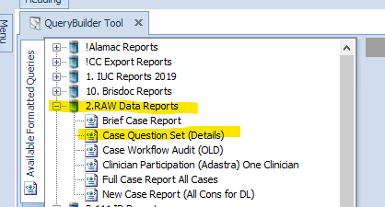

Enter the date range for the previous seven days, Tuesday till Tuesday.

EG: 04/02/2020 00:00 TO 11/02/2020 00:00

Select the run icon

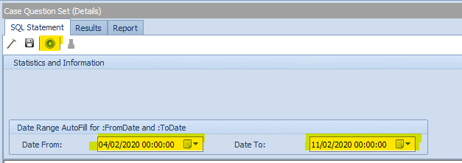

Select Report Filter: IUC ALL

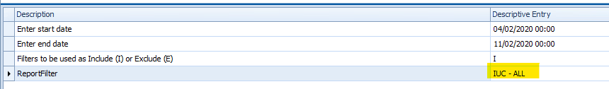

Click OK

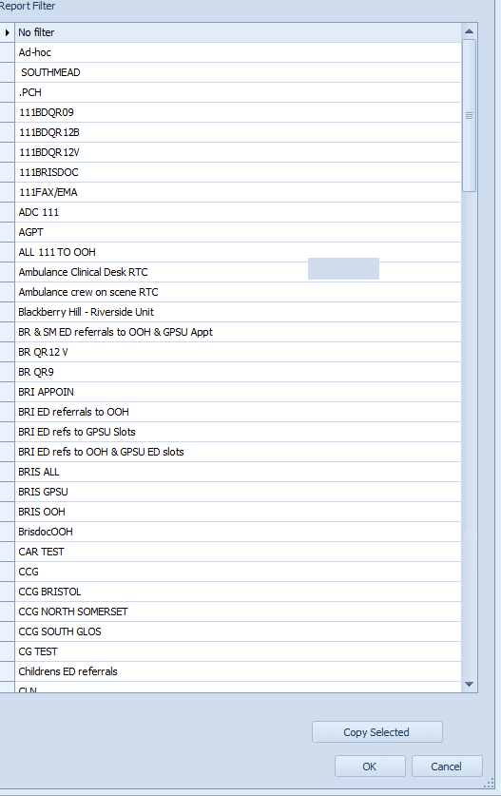

Wait for query to run and then select the results tab

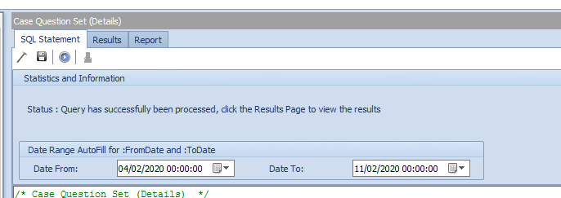

When list displays, export to the following folder: S:\GOVERNANCE TEAM\CONFIDENTIAL - DAC\LEARNING EVENTS\2019'20 work\Safeguarding\SG Audit

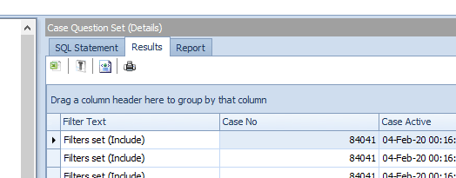

Save as: Audit Sample - todays date.

Open the sample, using the filters, filter column G to show the safeguarding questions and fliter column H to show any records where a ‘Y’ has been indicated as a response to a safeguarding question:

Copy and paste the records into the Safeguarding Audit Spreadsheet. As a very rough guide, you should expect to see in the region of 4 – 12 records.

Some cases may appear twice if both questions have been marked with a ‘Y’, only one case needs to be copied across per case number.

Using Adastra, search with the case number to find the NHS Number, Age and Postcode for each patient.

Save and Close.

The SG Lead will now review the list.

# Severnside Quality Dashboard

An excel spreadsheet dashboard created, maintained and monitored through the Severnside Quality Group. The dashboard is update monthly ahead of the Severnside Quality Group meeting.

The dashboard records the numbers of:

* Complaints
* Learning Events
* Health Care Professional Feedback Forms
* Safeguarding numbers
* NHS Pathways Compliance levels

The dashboard is populated by the BrisDoc Governance Team and the PPG members of the Severnside Quality Group and reviewed at each monthly meeting where any stand out trends or difference in the data will be discussed.

The dashboard is saved: S:\GOVERNANCE TEAM\2021'22 work\Severnside\Severnside Quality Database 2021'22 - master.xlsx

# Service Level Agreements

A service level agreement (SLA) is a commitment between a service provider and a customer. Particular aspects of the service – quality, availability, responsibilities – are agreed and set out in an SLA, which also defines the price, the level of service expected setting out the metrics and standards by which the service will be measured.

An SLA can be legally binding or informal. They may be time bound e.g. for a pilot.

A well-defined and typical SLA will contain the following components:

* **Type of service to be provided**: It specifies the type of service and any additional details of type of service to be provided.
* **The service's desired performance level, especially its reliability and responsiveness**: A reliable service will be the one that suffers minimum disruption in a specific amount of time and is available at almost all times. A service with good responsiveness will perform the desired action promptly after the customer requests it.
* **Monitoring process and service level reporting:** This component describes how the performance levels are supervised and monitored. This process involves gathering different type of statistics, how frequently these statistics will be collected and how they will be accessed by the customers.
* **The steps for reporting issues with the service**: This component will specify the contact details to report the problem to and the order in which details about the issue have to be reported. The contract will also include a time range in which the problem will be looked into and when the issue will be resolved.
* **Response and issue resolution time-frame**: Response time-frame is the time period by which the service provider will start the investigation of the issue. Issue resolution time-frame is the time period by which the current service issue will be resolved and fixed.
* **Repercussions for service provider not meeting its commitment**: If the provider is not able to meet the requirements as stated in SLA then service provider will have to face consequences. These consequences may include customer's right to terminate the contract or ask for a refund for losses incurred by the customer due to failure of service.

BrisDoc has SLAs with AWP for the Riverside Unit, Second Step for Health Link Workers in HHS.

A Memorandum of Understanding (MOU) has a similar purpose to an SLA. An example is the MOU between BrisDoc and AWP for HHS nurses working in joint roles.

# SEVERNSIDE GOVERNANCE TEAM / QUALITY GROUP

BrisDoc and PPG have established Governance and Patient Experience Teams working from Osprey Court and Nicholson House respectively. These teams will work collaboratively to ensure there is a seamless approach to governance across the interface of the services that make up SIUC. Within SIUC they will be collectively known as the Severnside Governance Team. The Team comprises:

|  |  |
| --- | --- |
| BrisDoc | PPG |
| Governance Manager | Regional Governance Manager |
| Quality Manager | Call Centre Manager |
| Patient Safety Co-ordinator | Patient Experience Team members |
| Patient Safety Administrator |  |

The Severnside Governance Team will support the SIUC monthly Quality Group Meetings at which complaints, Learning Events, compliments, safeguarding, etc. will be reported, reviewed and monitored.

The chair of the IUC Patient Representative Group is a member of the Quality group and attends the monthly meetings.

# Tackling Violence

Special Allocation Service (SAS) is a scheme where potentially violent patients are added to Tackling Violence list to alert services that they must only be refereed to SAS and seen in a secure setting.

Patients are added to the list and reviewed after a year; at this point they may be removed if appropriate.

A list of patients will be emailed from the ICB and received in [brisdoc.governance@nhs.net](mailto:brisdoc.governance@nhs.net) email in box and will include details of any names added to the scheme and also the names of patients who have been removed. The list can sometimes come in different formats, although should contain the name and NHS of each patient and whether they have been added or removed.

To notify a patient has been removed:



Close down original note that is open by obsoleting. And then add copy of new letter received from CCG with the following text (special note) as a new note.

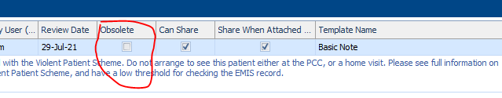

**The standard text to add to an SPN for patient who have been removed from the scheme is:**

This patient was previously registered with the Violent Patient Scheme, but was removed from the scheme on XX/XX/XX. Please check EMIS record for any recent information about the patient. If the patient requires face-to-face assessment during the OOH period, please consider arranging this at a base where more than one clinician is working. If there are current concerns about violence / aggression, please consider discussing the case with the Clinical Coordinator or Shift Manager to discuss the safest options for OOH clinical assessment.

**If a patient needs to be added, add a new note in Adastra, add following text:**

This patient is registered with the Violent Patient Scheme. Do not arrange to see this patient either at the PCC or a home visit. Please see full information on the toolkit about the Violent Patient Scheme, and check the EMIS record.

If the patients problem can wait for routine face to face assessment, they should be advised to ring

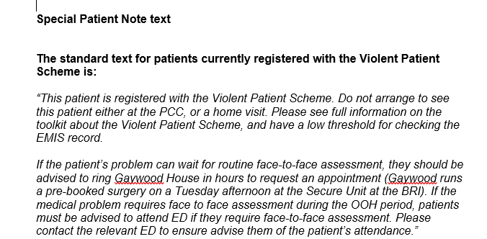

Also note If the address on the letter is different to Adastra information, please update Adastra with letter address as this is the most current location, edit this in patient edit within Adastra .

Ensure you tick these boxes on Adastra, so that information is shared before completing note.

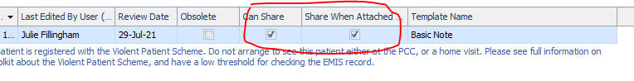

Reply back to ICB email, thanking them and confirming that our records have now been updated. Move emails to folder within Governance email.

# 