

Standard Operating Procedure for allocating cases via Adastra to individual clinicians

|  |  |  |
| --- | --- | --- |
| **Version:** | **Owner:** | **Created:** |
| 1 | Sri Jeyathaas | 01/02/2023 |
| **Published:** | **Approving Director:** | **Next Review** |
|  | Lucy Grinnell |  |

Contents

**Introduction 2**

**Roles and responsibilities 3**

**Objectives of the procedure 3**

**The Standard Operating Procedure 2**

**Operational Team 7**

**Clinician: 4**

Introduction

The purpose of this document is to set out the standard operating procedure (SOP) for how IUC cases on Adastra will be allocated to clinicians by WACCs from the IUC advice queue.

Roles and responsibilities

**WACC:** To allocate the cases to clinicians on Adastra at an appropriate pace that reduces admin time for clinicians and in turn should reduce the pressure on clinicians. Additionally, WACCs should actively communicate and take feedback from clinicians, this feedback should be used to ensure that allocations are as effective as possible.

**Shift Manager:** To confirm which WACC will be responsible for allocating during shift. To discuss with clinicians when to pick up cases outside of their allocated list.

**Clinician:** To focus on their allocated cases. To maintain open communication with WACCs including giving feedback on the process. Advise the Shift Manager if they need to take on a case outside of their allocated cases.

Objectives of the procedure

Through this process we aim to achieve the following:

* Reducing admin time for clinicians
* Ensuring appropriate cases are allocated to the right clinicians
* Improve wellbeing and reduce pressure for clinical staff by giving clinicians their own dedicated work queue away from the busy generic IUC advice queue

The Standard Operating Procedure

Adastra has a function where individual cases can be allocated to specific clinicians. This allocation process will require clinicians and operational staff to work together. Operational staff will allocate the cases to each clinician. Clinician’s will be able to see the cases allocated to them in their own work queue and deal with the case as usual. We are trialling this process throughout February to learn and evolve the process.

Operational Team:

For the purpose of the pilot, this process will only run when there is operational resource to sufficiently support it. This will be noted on the handover, along with which WaCC should undertake this role.

WACC to do Adastra allocation and collect feedback.

Shift Manager:

* The shift manager should note on MOTD which WaCC is managing allocation that shift
* When sending Adastra messages, include this process is active and advise which WaCC is managing it. Shift Managers may also want to encourage clinicians to make contact if they would like to be included in that shift’s trial of the process
* If 4 WACCs on shift, the Home Visit WACC should be responsible for doing Adastra allocation
* On occasions, another WACC may be chosen to do the allocation if more appropriate e.g., if there are less LIVI appointments and this WaCC has capacity or on weeknights where capacity allows

WACC:

* For the purpose of the pilot do not allocate to the Clinical Coordinator, Clinical Navigator or face to face clinicians at Treatment Centres
* Cases will be allocated in the same order clinicians work the IUC Advice queue; BLACK and RED cases should be prioritised, if there are not BLACK/RED cases on the queue, amber cases will then be prioritised for allocation. Priority tagged cases can also be allocated
* 3-4 cases should be allocated to each clinician before they start their shift
* As soon as a clinician starts their shift, instant message them to let them know that you are doing Adastra allocation for that shift and maintain communication through instant message e.g., if an allocated case isn’t appropriate for them
* Throughout the clinician’s shift, maintain a consistent flow of allocated cases, ideally drip feeding cases one at a time. This may not always be possible when juggling tasks and you may need to allocate more. There should be no more than three unlocked cases allocated at any one time. However, this should be allowed to go down to zero outstanding at times.
* Please aim to enable the clinician to clear the queue by the end of their shift, not to have cases left to reallocate
* Use the filter function on Adastra to monitor how many cases are currently allocated to each clinician
* Throughout your shift collect any feedback you receive from clinicians about allocations. Use the feedback template found in the **Appendix** to record this

Allocating the case on Adastra:

1. Right click on the case you want to allocate in the IUC Advice list.



2. Click on ‘**Allocate to Provider**’

3. After step 2, this box will open. Select the clinician you want to allocate the case to.

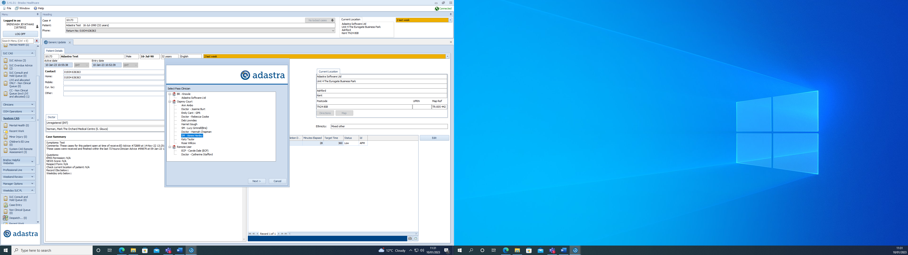

4. After selecting the clinician, press ‘**Next**’.

5. You will be taken back to IUC advice list and in the ‘Allocated’ column you will be able to see who the case has been allocated to, for example in this case “Admin Doctor”.



Reallocating the case on Adastra:

You may want to reallocate cases to a different clinician due to a few reasons such as:

* Patient needs have changed so a different type of clinician might be required
* Accidentally allocated to the wrong clinician
* Initial clinician that the case was allocated to has finished or is finishing their shift soon

Cases cannot be unallocated on Adastra so once they have been allocated to a clinician they can only be reallocated.

1. Right click on the case you want to reallocate.



2. Click on ‘**Allocate to Provider**’. Then follow steps 3 to 5 found in Allocating the case on Adastra.

Filter:

Use filter to monitor individual allocations

Cases can be filtered based on who they have been allocated to and whether they have been allocated.

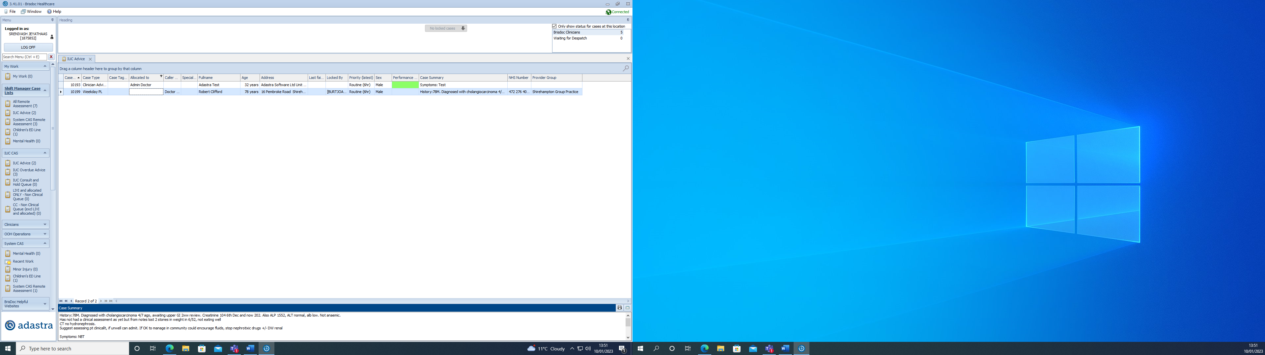

1. On the IUC Advice list, find the column titled ‘Allocated to’ or ‘Allocat….’. On the title you will see a small filter sign



3a. If you want to see all allocated cases, select All, then untick Blanks

3b. For cases allocated to specific clinicians, select only the specific clinicians

3c. To see all unallocated cases, only select Blanks

4. After selecting the appropriate option, press close.

2. Click the filter sign ad you will see a tick boxes for: All, Blanks, and each clinician that has case currently allocated to them.

Clinician role:

* On the left-hand side menu in Adastra, go to the “My Work” option, this should open a new queue which will show the cases that have been allocated to you
* The WACC allocating cases will instant message you on Adastra to let you know that they will be allocating
* Please work from your ‘My Work’ queue for the shift, however, if you need to pick up a case not allocated to you, please let the Shift Manager know
* Maintain open communication with the WACC through instant messaging on Adastra e.g., if you are to go on break or need the WACC to stop allocating due to a case being more complicated than expected
* Provide feedback on this process to the WACC
* If you wish to be included in Adastra allocation, message the shift manager and let them know, they will inform the WACC to start allocating you cases, where capacity allows

Reporting:

Weekly analyses

* The Allocation WaCC will collect feedback and fill out the template found in the Appendix A. This should be completed on the O Drive and saved so it can be accessed at a later date. A new form should be started for each shift - O:\Integrated Urgent Care Service (IUC)\WaCC Forms\Allocation
* WACC should note down in the template all the clinicians they were able to allocate cases to during their shift
* Team Managers will carry out Adastra reporting on a weekly basis during which they will assess how many cases have been allocated overall and by clinician, consultation length, and cases completed per hour for each clinician. The reporting template found in the Appendix B can be used for this

Appendix A - Feedback to WACC template (To be filled by WACC)

WACC:

|  |  |  |
| --- | --- | --- |
| **Clinicians given Adastra allocations:**   * A * A * A * A | | |
| Date and Shift | Clinician | Feedback |
|  |  |  |
|  |  |  |
|  |  |  |
|  |  |  |

Appendix B. Reporting Form:

|  |  |  |  |  |
| --- | --- | --- | --- | --- |
| **Date of shift:** | **Clinician:** | **Number of cases allocated:** | **Shift length:** | **Cases completed per hour:**  **(Number of cases allocated/Shift length)** |
| ***09/02/2023*** | ***Dr XXXX*** | ***14*** | ***6 hrs*** | ***2.5*** |
|  |  |  |  |  |
|  |  |  |  |  |
|  |  |  |  |  |
|  |  |  |  |  |
|  |  |  |  |  |
|  |  |  |  |  |