

Standard Operating Procedure for Handwashing Awareness Audit

Version: | Owner: | Created:
Version 1.0 | Shelly Joseph | 01/03/2026
Published: | Approving Director: | Next Review
19/03/2026 | Rhys Hancock | 01/03/2027

Contents
Introduction 3
Definitions 3
Associated Policy and National Guidance 3
Roles and responsibilities 3
Objectives of the SOP 4
The Standard Operating Procedure 4
Hosts – How to perform Handwashing Awareness 4
Hosts – How to record the Handwashing Awareness Audit 6
Clinicians 8
Governance and Reporting 9
Version Control 11

Introduction
BrisDoc is firmly committed to delivering the highest possible standard of Infection Prevention Control (IPC) that is both safe and clinically effective for all our patients, staff, and community.
Patients, Clinicians and Operations staff are put at potential risk of developing a healthcare-associated infection with contaminated hands. Hand hygiene is considered a primary measure for reducing the risk of transmitting infection among patients and health care personnel. It is the simplest but most effective way of preventing infection and the spread of disease.
The Handwashing Awareness Audit SOP explains the process required for Operational Hosts, all face to face Clinicians and Governance teams. The SOP includes awareness of the correct techniques of handwashing, the importance of good hand hygiene as well as how to record each encounter of handwashing and monitor the data to ensure the organisation is delivering on its hand-washing goals.

Objectives of the SOP
- Increase the awareness about the importance of hand hygiene within the organisation and share awareness of the new process through the Development Hub.
- Improve hand washing techniques among the clinicians, including the importance of a ‘bare below the elbow’ culture
- Encourage compliance with the Handwashing Awareness Audit for Operational and Clinical staff
- Aim for organisational goal of 95% compliance of Handwashing Awareness Audit which considers attrition and recruitment of patient facing clinical staff
- To fulfil our contractual obligations and report on monthly Handwashing Awareness Audit data

Definitions
Hand hygiene: The purpose of hand hygiene is to remove or destroy any pathogenic microorganism. This prevents microorganisms being transferred to other people protecting individuals. This can be achieved with a good hand-washing technique.
Infection prevention and control: Infection prevention and control (IPC) is a practical, evidence-based approach preventing patients and health workers from being harmed by avoidable infections.

Associated Policy and National Guidance
This SOP is to be read in conjunction with Brisdoc Infection Prevention and Control Policy and National Infection Prevention and Control guidance.

Roles and responsibilities
Hosts will access the development hub whilst on shift to identify any clinician at a Treatment Centre who needs an annual handwashing audit. This should then be completed and recorded against the competency check ‘Handwashing Audit’.
Clinicians are expected to fully comply with hand hygiene guidance set out in the IPC policy and undertake a handwashing audit once every 12 months. The episode of handwashing will be recorded on the Development Hub.
IPC Lead is expected to guide and support hosts and clinicians to follow IPC guidelines and be responsible for maintaining the IPC standards in each base including Handwashing awareness. The IPC Lead will monitor and report on the Handwashing Awareness Audit and will be actively working with Operational and Clinical teams to ensure that we achieve the target compliance.
Operational Team will be running reports monthly of the Handwashing Awareness Audit and liaise with the Clinical Admin Team and the IPC Lead.

The Standard Operating Procedure

Hosts

How to perform Handwashing Awareness
The Handwashing training kit is available at each Treatment Centre and comprises of Glitter Bug potion and an Ultraviolet (UV) torch.
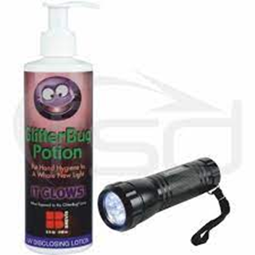 Glitter Bug Potion and UV torch.

How to use the Handwashing Kits
- Encourage clinicians to watch the video below for more information on how to perform handwashing https://www.radar-brisdoc.co.uk/knowledgebase/hand-washing-audit-guide/
- Refer to Appendix One.
- The Host should request the clinician rub the Glitter Bug potion all over their hands, including fingers and wrists. The Host then shines the UV torch on the clinician's hands to show the glitter which in this instance is acting as ‘bugs’ on the clinician's ‘dirty’ hands.
- The clinician then commences their handwashing using the correct handwashing techniques including drying the hands. See Appendix Two for a full list of instructions.
- The Host then shines the UV torch again on the Clinicians ‘clean’ hands. Any areas not washed properly will continue to glitter and will possibly need an improved handwashing technique as this is where potential germs could reside.

Hosts

How to record the Handwashing Awareness Audit

Step 1 – Identify Clinicians requiring a handwash
Log in to your Development Hub and go to menu tab Competency Checks. Select Group Member Checks.

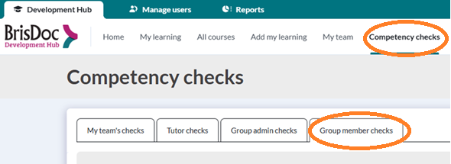

Step 2 – Select a Clinician
Find a clinician from the list whom you are on shift with and select the box Start Check
When choosing clinicians, prioritise those who are showing as overdue and very nearly due. To see the exact date that the check went overdue, click on the Exclamation Mark.
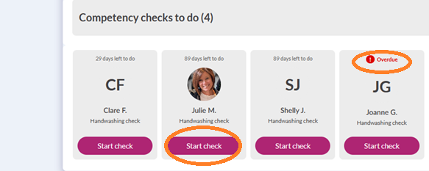

Step 3 – Record the Handwashing Awareness
Complete the Handwashing Awareness Audit process as explained in this SOP. Appendix Two has guidance on how to complete a handwashing audit.

Step 4 – Record completion
Once the handwashing audit is completed, select Pass to demonstrate that the check has been completed. There is no ‘pass’ or ‘fail’ – only a ‘pass’.

Use the comments section to enter your name:
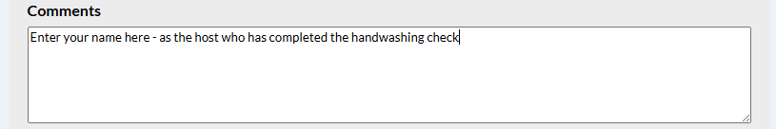
Enter the date that the check was completed and select Save.


Clinicians
All patient facing clinicians can access the Development Hub to view individual handwashing audit data using the link below and selecting the highlighted icon:
https://brisdoc.co.uk/weblinks/
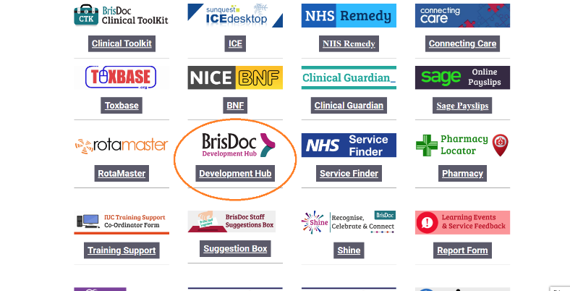
The Handwashing Awareness module must be completed annually.
Please take the opportunity when in a Base to let the Host know if you are outstanding a Handwashing Awareness Audit.
The Handwashing Awareness module must be done in the presence of a Host. The Host will follow the SOP which stipulates the clinician must be observed using the Glitterbug lotion, the UV torch and performing the handwashing process. These components constitute the annual Handwashing Audit for a clinician.

Before performing hand hygiene:
- expose forearms (bare below the elbow).
- if disposable over-sleeves are worn for religious reasons, these must be removed and disposed of before performing hand hygiene, then replaced with a new pair​.
- remove all hand and wrist jewellery. The wearing of a single, plain metal finger ring, e.g. a wedding band, is permitted but should be removed (or moved up) during hand hygiene.
- A religious bangle can be worn but should be moved up the forearm during hand hygiene and secured during patient care activities.
- ensure fingernails are clean and short, and do not wear artificial nails or nails products.
- cover all cuts or abrasions with a waterproof dressing.

Wash hands with non-antimicrobial liquid soap and water if:
- hands are visibly soiled or dirty.
- caring for patients with vomiting or diarrhoeal illnesses
- caring for a patient with a suspected or known gastrointestinal infection, e.g. norovirus or a spore-forming organism such as clostridium difficile.
- in all other circumstances, use alcohol-based handrubs (ABHRs) for routine hand hygiene during care.
- ABHRs must be available for staff as near to the point of care as possible.
- Where this is not practical, personal ABHR dispensers should be used, e.g. within the community, on a home visit.
- Where running water is unavailable or hand hygiene facilities are lacking, staff may use hand wipes followed by ABHR and should wash their hands at the first opportunity.

Perform hand hygiene:
- before touching a patient.
- before clean or aseptic procedures.
- after body fluid exposure risk
- after touching a patient; and
- after touching a patient’s immediate surroundings

Please see Appendix One for handwashing techniques and observe the Severnside video for further guidance.

Governance and Reporting

Monthly Handwashing Awareness Audit
A monthly report of handwashing awareness data can be extracted from the Development Hub. The Service Delivery Team (part of Operations Team) will run a monthly report by the 5th of each month and share with IPC Lead, Head of IUC, Clinical Admin Team, Operations Lead and Host Lead.
The IPC Lead will share data with Health and Safety Board monthly. This audit will also fulfil our contractual obligations and performance data will be shared with commissioners.

Adding/ Removing Hosts and Clinicians
Clinicians and Hosts will be uploaded from rota master automatically to the Development Hub as part of the on-boarding check list. This will be a weekly update process. A similar weekly process will remove Clinicians and Hosts from the Development Hub if employment is ceased.
The Clinical Admin Team or the Rota Team (dependent on self-employed / employed status) will email Workforce Support to advise if a new clinician will not be seeing patients face to face. The Workforce Support Team will then remove the requirement for a Handwashing Awareness Audit from the clinicians Development Hub.
Similarly, if a Clinician or Operations member changes their role to Face to Face or Host respectively then the Clinical Admin Team or the Rota Team will inform the Workforce Team appropriately.

Version Control
Date | Version | Author | Change Details
February 2026 | New | Shelly Joseph | New SOP replacing SOP for Handwashing Audits for Hosts 01/06/2023

Appendix one – Handwashing techniques
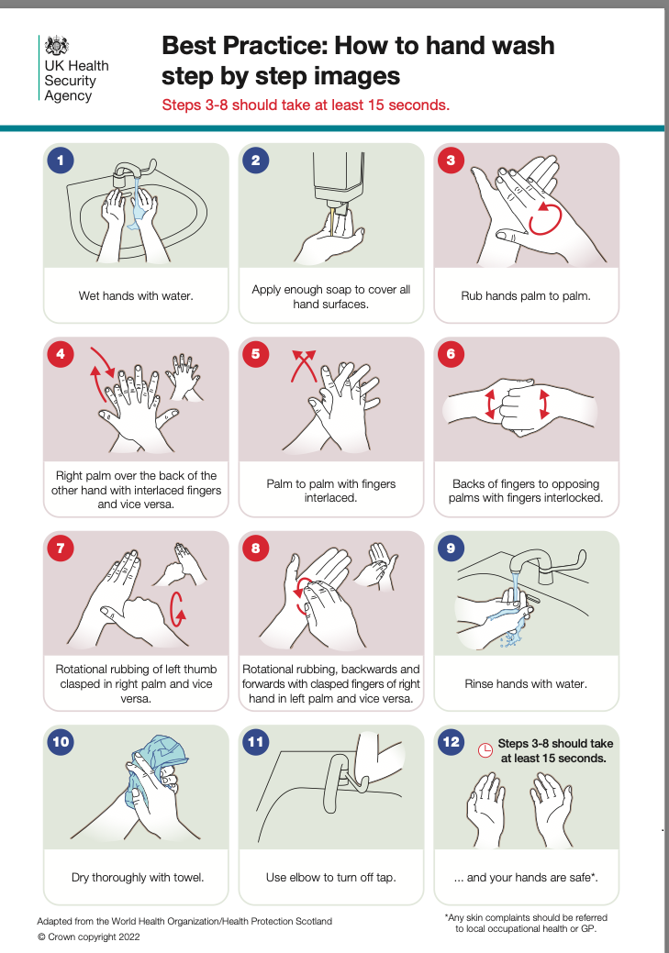

Appendix Two - Handwashing Awareness Steps
Clinicians name | Host Name
Date | Base
Handwash preparation:
Bare below the elbows
Remove all jewelry
Reminder: fingernails should be clean, short and free from any nail products
Clinician to apply Glitter bug spray all over front, back of hands and wrists
Host shines UV light on clinicians' hands to show where bugs may sit. This will show up as glittery patches under the light.
Handwashing steps:
Wet hands thoroughly with water
Apply enough soap to cover all hand surfaces
Rub hands palm to palm
Right palm over the back of the other hand with interlaced fingers and vice versa
Rub palm to palm with fingers interlaced.
Back of fingers to opposing palms with fingers interlocked
Rotational rubbing of left thumb clasped in right palm and vice versa
Rotational rubbing, backwards and forwards with clasped fingers of right hand in the left palm and vice versa
Rub each wrist with opposite hand
Rinse hands with water
Close tap using elbow
Dry thoroughly with paper towels
Paper towels are disposed of without touching the waste bin lid
Repeat hand check:
Shine UV light on clean hands and if no white marks show then hands have been cleaned thoroughly
Recording the audit:
Host to log results on Handwashing Awareness on the development hub

