Homeworking DSE Risk Assessment
Instructions: This form is designed to assess your workstation setup to ensure it is safe and comfortable at home.
Name |  | Home Address
Service |  | Date of Assessment
This risk assessment is to be completed by all employees who work from home.

The purpose of this assessment is to assist your manager in safeguarding your health and safety whilst you are homeworking.
 | Work Environment Checklist
 | This checklist id for use by staff who work at home to enable them to be sure that their workstation is safe, comfortable and practical. See DSE seating and posture diagram in appendix 3. | Yes | No
1 | Do you have a separate work area way from the rest of the living space where you can work without disruption and maintain confidentiality?
2 | Is there sufficient secure storage for confidential information both at home and in transit?
3 | Do you have enough space to work safely?
4 | Are there sufficient electrical sockets to enable you to safely plug in your laptop or computer?
5 | Is the work area clear from obstructions and tripping hazards?
6 | Do you know how to report work related accidents?
7 | Do you know how to report health and safety concerns?
8 | Is there room for a PC to fit comfortably on a desk?
9 | Do you have sufficient workspace to avoid placing items on the floor?
10 | Is existing lighting adequate for computer work and reading?
11 | Are appropriate communication channels in place for contact with colleagues and managers?
12 | Are you happy that workload targets have been agreed and are achievable?
13 | Have you received suitable and sufficient instruction on your hardware and software?
14 | Do you need support to make any adjustments to work at home safely? Chair, Table, screen riser, external keyboard/mouse
15 | Is there a need for non-business or business visitors to arrive at the premises while you are home working? (Business meetings should not take place at home)

If the answer to questions 1-13 is No, or the answer to questions 14- 15 is Yes, the line manager must ensure that the home environment is appropriate for work. Your line manager should refer to the DSE policy which can be found on Radar and speak with the workforce support team for further guidance if required.

This checklist has been completed to the best of my knowledge. I confirm that I will be able to work at home safely and effectively. If, for any reason, circumstances change and I feel that I will no longer be able to do so, I understand it is my responsibility to report it to my line manager as soon as reasonably practicable.

Staff Name |  | Signature |  | Date
Manager's Name |  | Signature |  | Date

B. Posture and Chair  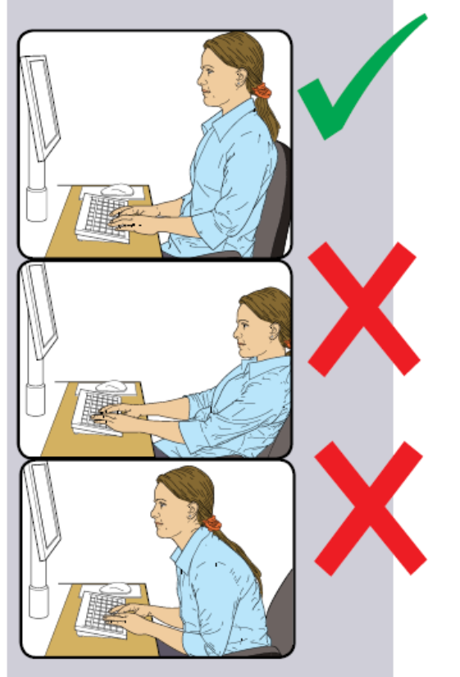  C. Workstation Surface | D. Display Screen  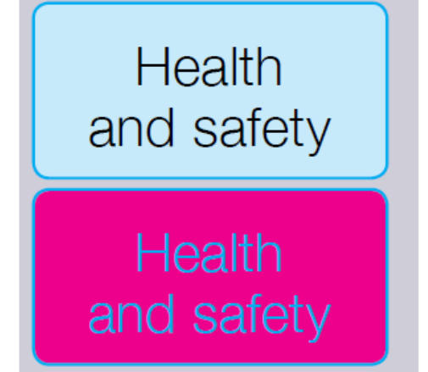  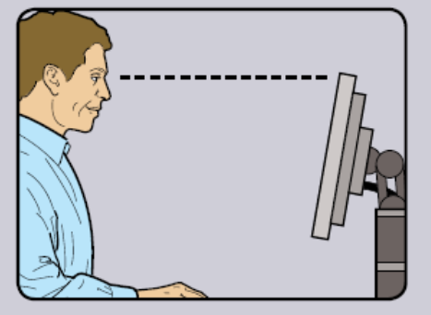  

E. Keyboard | F. Mouse

