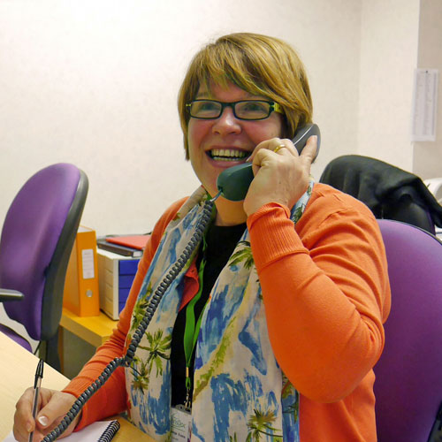
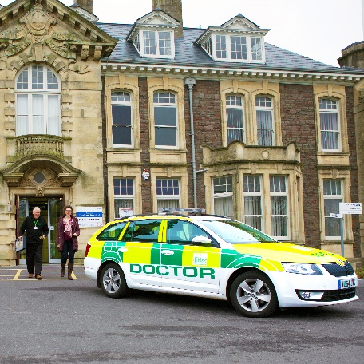
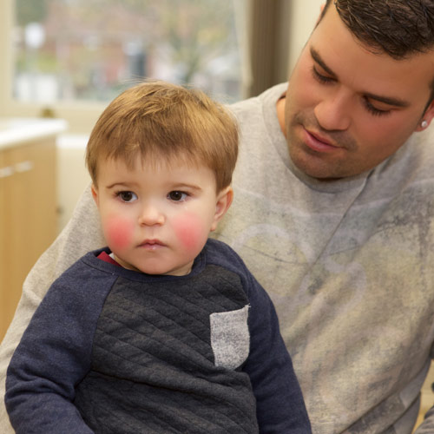
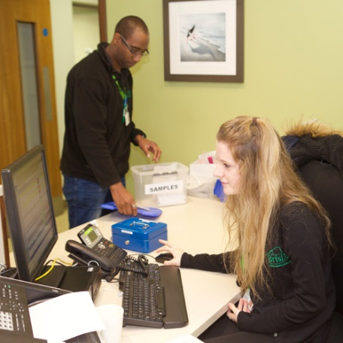
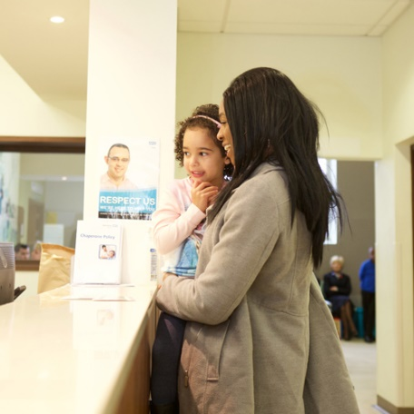

Greenway IT Guidance

Contents
Introduction 3
PC setup 4
Telephone setup 6
IT trouble shooting guide 10

Introduction
This handbook has been created as a guide for new Hosts and a reference point for anyone carrying out the Host role.

PC setup
Each room has been set up the same with our PC’s at the bottom and Greenway Community Practice at the top.
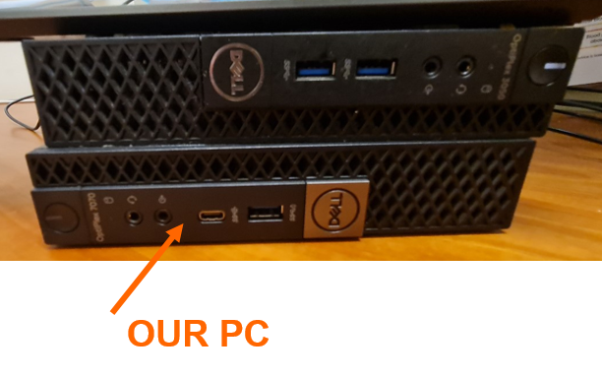
Firstly, we need to place any equipment that’s not ours behind the PC. This might include keyboard, mouse and smartcard reader.
Then take our equipment out and set our PC up.
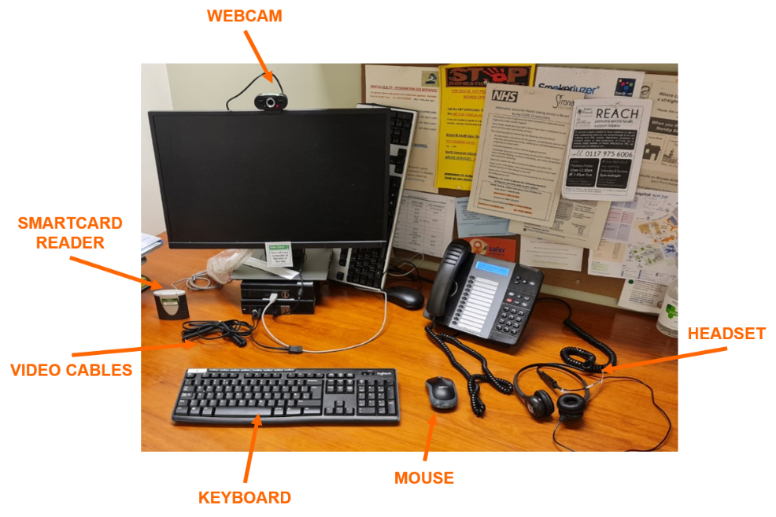
When connecting the adaptor for the headset, it should be set so the mic cable is plugged in on the left and the headphones are on the right.
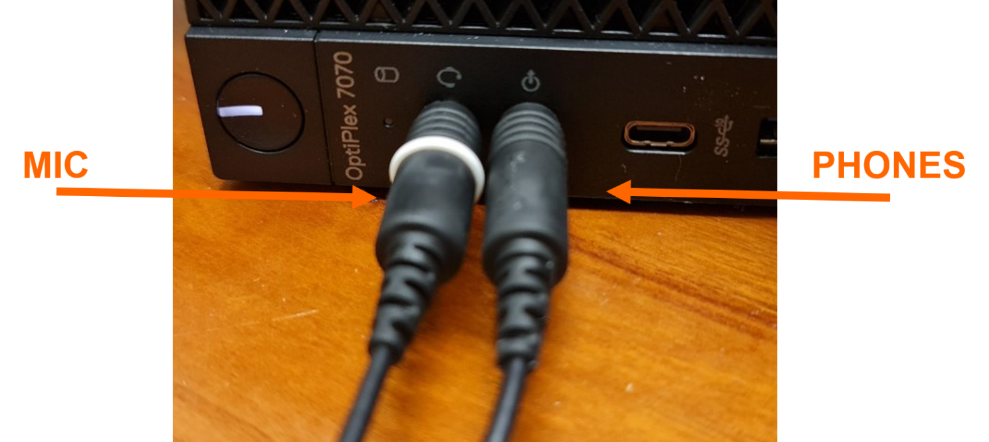

When you plug the adaptor in the PC may ask what settings to apply. For the first message, press ‘OK’.
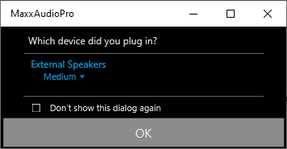
This will then bring a second message up asking which device you plugged in, select ‘Microphone in’, then press ‘OK’.
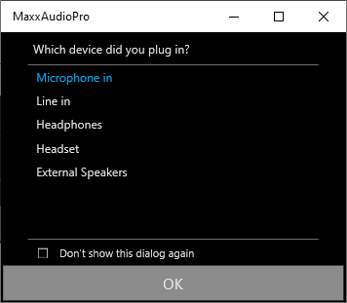

Telephone setup
Each of the clinician’s rooms should come with a headset. Depending on how the clinician will want to work there are different ways to set the phone up.
Some rooms will come setup with a headset adaptor.
This will allow both the normal handset and the headset to be connected at the same time. If there is no adaptor, either the handset or the headset can be connected, both cannot be connected at the same time without the above adaptor.

No headset- without adaptor
If the clinician does not want to use the headset and there is no adaptor, then the handset needs to be connected to the handset socket on the back of the phone.

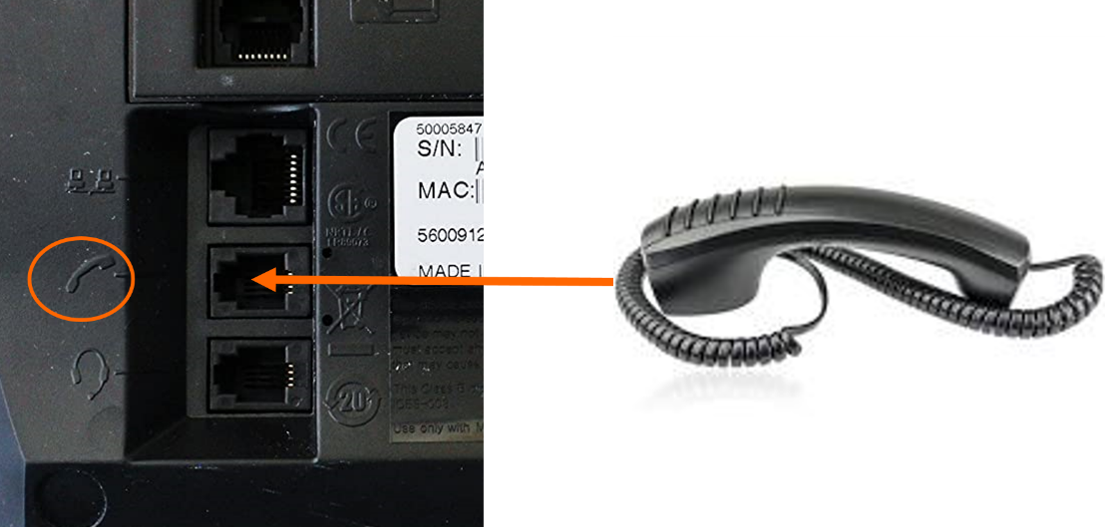

No headset- with adaptor
If the clinician does not want to use the headset and there is an adaptor then the adaptor needs to be connected to the handset socket on the back of the phone. The handset connected to the adaptor where the socket shows handset.
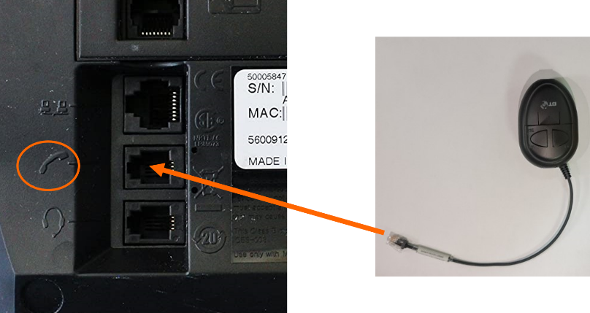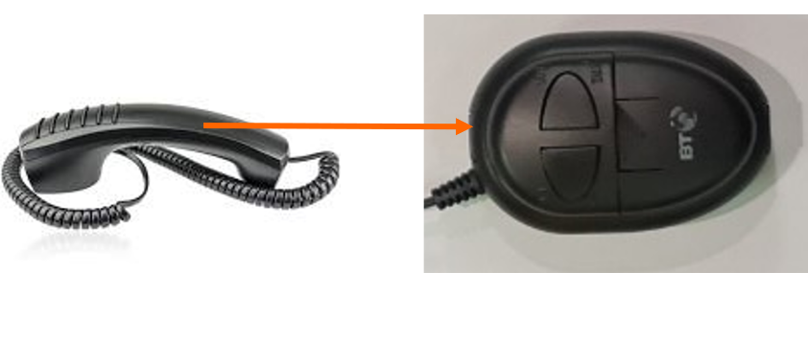

To use the handset button 1 show in the picture below needs to be up. Button 2, if down is muted, if up then you are able to talk.

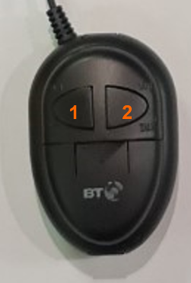

Headset- without adaptor
If the clinician wants to use the headset and there is no adaptor then the handset needs to be connected to the handset socket on the back of the phone. To answer the phone you will still need to pick up the handset and place next to the phone. Note there is a 2 or 3 second delay before cloudcall will start to ring the patient.
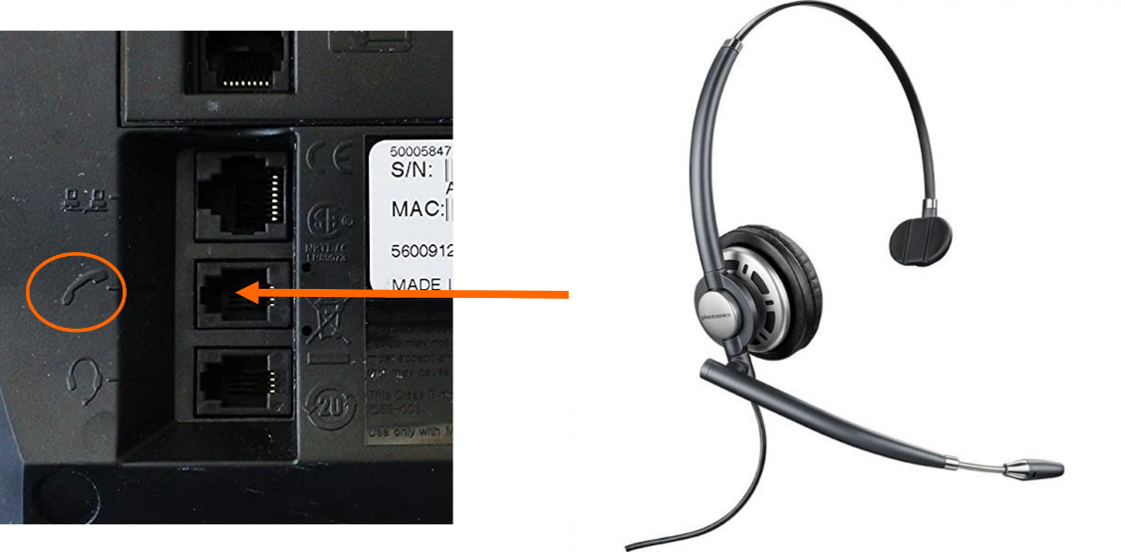

Headset- with adaptor
If the clinician wants to use the headset and there is an adaptor then the adaptor needs to be connected to the handset socket on the back of the phone. The handset connected to the adaptor where the socket shows handset and the headset connected to socket that shows headset.
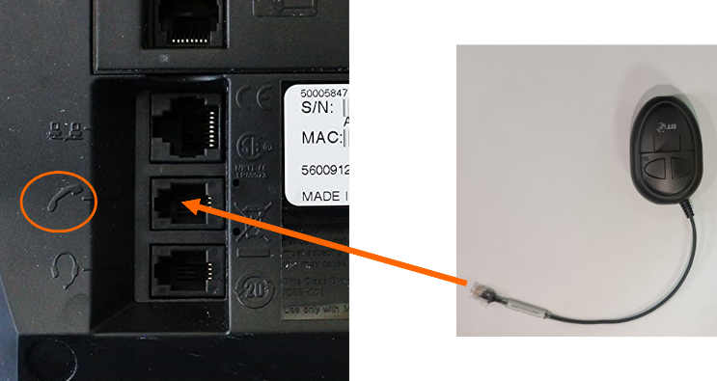
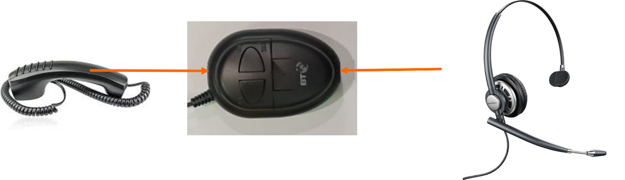To use the headset button 1 show in the picture below needs to be down. Button 2, if down is muted, if up then you are able to talk.

To answer the phone you will still need to pick up the handset and place next to the phone. Note there is a 2 or 3 second delay before cloudcall will start to ring the patient

IT trouble shooting guide
Below are some common issues that you might come across with possible fixes, if you are still not sure then speak to the ASM or shift manager who may be able to help.
Issues | Possible Fix
Keyboard or Mouse is not working | Are we using our keyboards? (Wireless ones)  Is it the correct keyboard and mouse? (is it labelled correctly)  Is the keyboard and mouse switched on?  Does the battery need replacing?  Is the screen displaying our screen or Greenway Community practice
Smartcard not working | Is the Smartcard reader connected to our PC?  Has the clinician used this recently?  Try restarting the PC?  Is the Smartcard locked? This might need to be checked by the ASM or Shift Manager.
Cloudcall shows already logged in | If Couldcall shows that the account is already logged in, then this will need to ASM or Shift Manager to go in and remove the current user and this should allow you to log back in. This usually happens if the window is closed and not logged out properly
Unable to Electronically prescribe | If the patients demographics do not match the NHS spine then the clinician may not be able to electronically prescribe, there is guidance on the Clinical toolkit. Search ‘How to validate cases on Adastra so you can EPS’  If you get the error message ‘Error retrieving data from server’ this is usually due to the fact the nearest pharmacies are closed. Click ‘Advanced’, then ‘OK’, then select ‘Search by Name and postcode’ and search for Pharmacy this way. Pharmacy details can be found on Brisdoc Weblinks under ‘Pharmacy Locator’
NHS Mail Issues | If when you open NHS Mail it keeps opening an old account then you need to logoff the account, close the tab and then close the whole browser, reopen the browser and this should then let you log in.
Adastra error – Cannot start app -= “Adastra V3 Live – Brisdoc” | If you see this message when trying to open Adastra then we have used all of our licences available, you may need to speak to the ASM or Shift Manager to see if there are any PC’s that can be logged out at another base.
Sound not working on PC | Is the sound turned up? Is the sound on mute?  Try right clicking on the sound icon on the taskbar, press ‘open volume mixer’ and check if any of the system sounds are turned up and are not muted.
Cloudcall not calling the phone in my room | Is the phone logged in to the correct extension number?  Is cloudcall logged into the correct login details?  Try logging everything out then logging back in.
Unable to print a prescription | There is no access to a prescription printer at Greenway. For stock items, a manual prescription will be required. All other prescriptions need to be sent electronically.
Unable to print patient notes/referrals | Patient notes no longer need to be printed as they will be available on connecting care within a maximum of 45 minutes. If any referral forms need to be sent off then they can be sent using the SOP for sending onward referral notes in Severnside IUC

